**SUBJECT : ENVIRONMENTAL PROTECTION TECHNICAL SPECIFICATIONS (NOISE) APPLICABLE TO VTOL-CAPABLE AIRCRAFT POWERED BY TILTING ROTORS**

**REQUIREMENTS incl. Amdt. : Regulation (EU) 2018/1139, Article 9(2), Annex III**

**ASSOCIATED IM/MoC[1] :** Yes/ No*[*

**ADVISORY MATERIAL : --**

**INTRODUCTORY NOTE:**

The Agency has received applications for the certification of aircraft with vertical take-off and landing capability (VTOL) for which no suitable environmental protection standards (i.e. noise, engine emissions, CO2 emissions) are presently available in Annex 16 to the Chicago Convention. The Agency needs therefore to develop a new regulatory framework in line with the provisions of the essential requirements for environmental compatibility contained in Annex III of the Regulation (EU) 2018/1139 (BR) and related to the certification of the product design.

The BR allows the Commission to develop further detailed environmental protection requirements under the delegated powers of Article 19(1)(a), for manned aircraft, and under Article 58(1)(a) for unmanned aircraft.

Article 76(3) of the BR mandates the Agency to issue certification specifications and other detailed specifications, acceptable means of compliance and guidance material for the application of the Basic Regulation and of the delegated and implementing acts adopted on the basis thereof.

As an interim measure before such requirements are adopted, EASA is issueing Environmental Protection Technical Specifications (EPTS) to ensure that environmental protection is taken into consideration in the design of these new aircraft.

Once sufficient knowledge and experience has been acquired, the necessary regulatory changes will be initiated through an Opinion of the Agency containing proposals for a delegated act to be adopted by the Commission as stipulated in the BR.

The following EPTS are proposed for aircraft with vertical take-off and landing capability (VTOL) powered by tilting rotors. They contain the noise technical specifications and procedures that the applicants can use to demonstrate compliance with the essential environmental protection requirements in the Basic Regulation when applying for a type certificate.

The present noise technical specifications are based on the content of Chapter 13 of ICAO Annex 16 Volume I and associated Evaluation Method of Appendix 2 and Guidance Material from ICAO ETM, which applies to tilt-rotors, to facilitate the comparison of technologies . The procedures are adapted to the characteristics of VCA with tilting rotors where necessary, for instance, by extending the lower test height limit to anticipate the lower noise signature of VCA, or by allowing a more refined source noise correction than for conventional tilt-rotors. The maximum allowable noise levels are kept identical to those of the [EPTS for VCA designs involving non-tilting rotors](https://www.easa.europa.eu/en/document-library/product-certification-consultations/consultation-paper-environmental-protection) while EASA collects more noise data from such designs through certification projects. In addition, in order to aid the noise assessment of operations in the vicinity of vertiports, a hover noise assessment has been developed.

While the current EPTS apply to VCA with tilting rotors, EASA has already developed and publicly consulted separate [EPTS for VCA designs involving non-tilting rotors](https://www.easa.europa.eu/en/document-library/product-certification-consultations/consultation-paper-environmental-protection). It should also be noted that, while the weight applicability of the current EPTS overlaps with that of the “[Guidelines on Noise Measurement of Unmanned Aircraft Systems Lighter than 600 kg Operating in the Specific Category (Low and Medium Risk)](https://www.easa.europa.eu/en/document-library/product-certification-consultations/guidelines-noise-measurement-unmanned-aircraft)”, the latter cover drones within the ‘Specific’ category of operations whereas the former covers certain air taxi designs (both manned or unmanned) within the ‘Certified’ category of operations. Consequently, the current EPTS and the UAS guidelines have distinct applicability scopes.

**ENVIRONMENTAL PROTECTION TECHNICAL SPECIFICATIONS (NOISE) APPLICABLE TO VTOL-CAPABLE AIRCRAFT POWERED BY TILTING ROTORS**

Table of contents

Table of contents 3

Table of figures 6

Table of tables 6

SUBPART A - GENERAL 7

NVTOL-TILT.1000 - Applicability 7

NVTOL-TILT.1005 - Definitions 7

SUBPART B - NOISE EVALUATION METRICS 8

NVTOL-TILT.1100 - Applicable noise evaluation metrics 8

NVTOL-TILT.1105 - Calculation of Effective Perceived Noise Level 8

MoC1 NVTOL-TILT.1105 - Calculation of Effective Perceived Noise Level 13

IM1 NVTOL-TILT.1105 - Calculation of Effective Perceived Noise Level 14

NVTOL-TILT.1110 - Calculation of A-weighted equivalent continuous sound pressure level 14

SUBPART C - REFERENCE CONDITIONS AND PROCEDURES 16

NVTOL-TILT.1200 - Reference noise measurement points 16

IM1 NVTOL-TILT.1200 - Reference noise measurement points 16

NVTOL-TILT.1205 - Reference procedures 18

NVTOL-TILT.1210 - Reference atmospheric conditions 20

SUBPART D - MAXIMUM ALLOWABLE NOISE LEVELS 21

IM1 SUBPART D Maximum Allowable Noise Levels 21

SUBPART E - NOISE TEST 22

NVTOL-TILT.1400 - Test environment conditions 22

MoC1 NVTOL-TILT.1400 - Test environment conditions 23

MoC2 NVTOL-TILT.1400 - Test environment conditions 23

IM1 NVTOL-TILT.1400 - Test environment conditions 26

IM2 NVTOL-TILT.1400 - Test environment conditions 26

NVTOL-TILT.1405 - Flight test procedures 26

MoC1 NVTOL-TILT.1405 - Flight test procedures 28

MoC2 NVTOL-TILT.1405 - Flight test procedures 30

IM1 NVTOL-TILT.1405 - Flight test procedures 30

IM2 NVTOL-TILT.1405 - Flight test procedures 30

IM3 NVTOL-TILT.1405 - Flight test procedures 32

IM4 NVTOL-TILT.1405 - Flight test procedures 33

NVTOL-TILT.1410 - Noise measurement 34

MoC1 NVTOL-TILT.1410 - Noise measurement 36

MoC2 NVTOL-TILT.1410 - Noise measurement 36

MoC3 NVTOL-TILT.1410 - Noise measurement 36

IM1 NVTOL-TILT.1410 - Noise measurement 36

NVTOL-TILT.1415 - Spatial positioning and speed measurement 37

MoC1 NVTOL-TILT.1415 - Spatial positioning and speed measurement 37

IM1 NVTOL-TILT.1415 - Spatial positioning and speed measurement 38

SUBPART F - NOISE TEST EQUIPMENT 39

NVTOL-TILT.1500 - Noise measurement system 39

NVTOL-TILT.1505 - Microphone system characteristics and set-up 39

MoC1 NVTOL-TILT.1505 - Microphone system characteristics and set-up 41

MoC2 NVTOL-TILT.1505 - Microphone system characteristics and set-up 41

MoC3 NVTOL-TILT.1505 - Microphone system characteristics and set-up 41

IM1 NVTOL-TILT.1505 - Microphone system characteristics and set-up 42

NVTOL-TILT.1510 - Recording and reproducing system 43

MoC1 NVTOL-TILT.1510 - Recording and reproducing system 43

MoC2 NVTOL-TILT.1510 - Recording and reproducing system 43

MoC3 NVTOL-TILT.1510 - Recording and reproducing system 44

IM1 NVTOL-TILT.1510 - Recording and reproducing system 44

IM2 NVTOL-TILT.1510 - Recording and reproducing system 44

NVTOL-TILT.1515 - Analysis system 44

MoC1 NVTOL-TILT.1515 - Analysis system 45

MoC2 NVTOL-TILT.1515 - Analysis system 45

IM1 NVTOL-TILT.1515 - Analysis system 46

IM2 NVTOL-TILT.1515 - Analysis system 46

NVTOL-TILT.1520 - Calibration systems 47

SUBPART G - CONFORMITY PROCEDURE 48

NVTOL-TILT.1600 - Adjustments of the measured sound levels 48

MoC1 NVTOL-TILT.1600 - Adjustments of the measured sound levels 52

MoC2 NVTOL-TILT.1600 - Adjustments of the measured sound levels 57

MoC3 NVTOL-TILT.1600 - Adjustments of the measured sound levels 63

IM1 NVTOL-TILT.1600 - Adjustments of the measured sound levels 63

IM2 NVTOL-TILT.1600 - Adjustments of the measured sound levels 63

IM3 NVTOL-TILT.1600 - Adjustments of the measured sound levels 63

NVTOL-TILT.1605 - Satisfying maximum allowable noise levels 64

IM1 NVTOL-TILT.1605 - Satisfying maximum allowable noise levels 66

SUBPART H - REPORTING 69

NVTOL-TILT.1700 - Noise data 69

NVTOL-TILT.1705 - Aircraft information 70

NVTOL-TILT.1710 - Additional test information 71

Table of figures

Figure 1: Perceived Noisiness as a function of Sound Pressure Level 12

Figure 2: Example of a noise time history 14

Figure 3: side view of the reference noise measurement points of the hover procedure 17

Figure 4: top view of the reference noise measurement points of the hover procedure 17

Figure 5: depiction of allowable flight boundaries for the hover procedure 30

Figure 6: Comparison of measured and reference take-off profiles 31

Figure 7: Comparison of measured and reference overflight profiles 33

Figure 8: Comparison of measured and reference approach profiles 34

Figure 9: illustration of sound incidence angles on a microphone and positioning for noise measurements 42

Figure 10: Determination of SLOW timestamp from analysis start time 47

Figure 11: Single-point flight path descriptors 59

Figure 12: Detailed CPA geometry 61

Figure 13: depiction of reference flight path and sound propagation 62

Table of tables

Table 1: Tone Correction factors 10

Table 2: Constants for mathematically formulated noy values 13

Table 3: maximum allowed noise levels of the aircraft as a function of MTOM 21

Table 4: Values of η(δ) 25

Table 5: Values of f0 25

Table 6: microphone system directional response specifications 40

SUBPART A - GENERAL

## NVTOL-TILT.1000 - Applicability

These Environmental Protection Technical Specifications apply to VTOL-capable aircraft (VCA) powered by rotors mounted on tiltable axes, where a VCA is defined as a power-driven, heavier-than-air aircraft, other than aeroplane or rotorcraft, capable of performing vertical take-off and landing by means of lift and thrust units used to provide lift during take-off and landing.

## NVTOL-TILT.1005 - Definitions

*Noise measurement point*: the noise measurement point is the point where the microphone is located.

*Test (or Noise Test)*: designates the collection of all field measurements carried out to obtain the sound levels of the aircraft. A test comprises of several test runs, and the noise test campaign comprises of several test (or noise tests).

*Test run*: designates only one occurrence of a test procedure, for instance one aircraft flight over the noise measurement point.

*Nacelle*: designates the tiltable components on which the rotors are mounted.

*Nacelle angle*: designates the tilt angle of the nacelle. When the aircraft is flying in the aeroplane mode, the nacelle angle is near 0°, in line with the longitudinal axis of the aircraft. A nacelle angle around 90° corresponds to rotors oriented with their axis of rotation substantially vertical. In the current document, although used in the singular form, “*nacelle angle*” can refer to different angle values for every nacelle.

*VCON (conversion speed)*: designates the maximum authorized speed for VTOL/conversion mode at a specific nacelle angle.

*VMCP*: maximum operating limit airspeed for aeroplane mode corresponding to minimum engine installed, maximum continuous power (MCP) available for sea level pressure (1 013.25 hPa), 25°C ambient conditions at the relevant maximum certificated mass.

*VMO*: maximum operating limit airspeed that may not be deliberately exceeded.

The values of VCON, VMCP and VMO used for noise evaluation should be quoted in the approved flight manual.

In all Subparts of the present document, “the aircraft” refers to the design to which this document is applicable as well as to the test vehicle used to satisfy the specifications set forth in this document.

SUBPART B - NOISE EVALUATION METRICS

## NVTOL-TILT.1100 - Applicable noise evaluation metrics

For the take-off, overflight and approach reference procedures specified in “NVTOL-TILT.1205 - Reference procedures”, the noise evaluation metric is the Effective Perceived Noise Level (EPNL) measured in EPNdB, as defined in “NVTOL-TILT.1105 - Calculation of Effective Perceived Noise Level”.

The A-weighted continuous sound pressure level (LAeq) as defined in “NVTOL-TILT.1110 - Calculation of A-weighted equivalent continuous sound pressure level” is used for the hover procedure specified in “NVTOL-TILT.1205 - Reference procedures”.

## NVTOL-TILT.1105 - Calculation of Effective Perceived Noise Level

1. General
   1. The metric used to quantify the measured noise level in the take-off, overflight and approach procedures of “NVTOL-TILT.1205 - Reference procedures” is the Effective Perceived Noise Level (EPNL) expressed in units of EPNdB.
   2. The noise levels are first acquired as instantaneous sound pressure levels in spectra composed of 24 one-third octave bands, which are obtained for each one-half second increment of time throughout the duration over which the aircraft noise is measured, using SLOW-time weighting. Specifications for one-third octave band filters are found in “NVTOL-TILT.1515 - Analysis system”.
   3. The EPNL calculation procedure consists of the five following steps:
      1. Each of the 24 one-third octave band sound pressure levels in each measured one-half second spectrum is converted to perceived noisiness by the method in paragraph “(g)” of “NVTOL-TILT.1105 - Calculation of Effective Perceived Noise Level”. The noy values are combined and then converted to instantaneous perceived noise level, PNL(k), at the kth instant of time, by the method of paragraph “(b)” of “NVTOL-TILT.1105 - Calculation of Effective Perceived Noise Level”.
      2. For each spectrum a tone correction factor, C(k), is then calculated by the method of paragraph “(c)” of “NVTOL-TILT.1105 - Calculation of Effective Perceived Noise Level”.
      3. The tone correction factor is added to the perceived noise level to obtain the Tone Corrected Perceived Noise Level, PNLT(k), for each spectrum:

PNLT(k) = PNL(k) + C(k).

* + 1. From the history of PNLT(k) noise levels, the maximum value PNLTM is determined by the method of paragraph “(d)” of “NVTOL-TILT.1105 - Calculation of Effective Perceived Noise Level” and the noise duration is determined by the method of paragraph “(e)” of “NVTOL-TILT.1105 - Calculation of Effective Perceived Noise Level”.
    2. The Effective Perceived Noise Level, EPNL, is determined by logarithmic summation of the PNLT levels over the noise duration and by normalizing the duration to 10 seconds, by the method of paragraph “(f)” of “NVTOL-TILT.1105 - Calculation of Effective Perceived Noise Level”.

1. Perceived Noise Level

Instantaneous Perceived Noise Levels, PNL(k) (with unit “PNdB”), are calculated from instantaneous one-third octave band Sound Pressure Levels, SPL(l,k), where “l” represents the index of the one-third octave band starting from 50 Hz (l=1 for the band centred at 50 Hz, l=24 for the band centred at 10 kHz), according to the following steps:

* + 1. *Step 1*: Convert each one-third octave band, SPL(l,k), from 50 Hz to 10 kHz, to Perceived Noisiness, PN(l,k), by reference to the mathematical formulation of paragraph “(g)” of “NVTOL-TILT.1105 - Calculation of Effective Perceived Noise Level”.
    2. *Step 2*: the value of Total Perceived Noisiness TPN(k) is obtained at every kth instant of time from the Perceived Noisiness PN(l,k) of Step 1 through the following formula, where PNmax(k) is the largest of the 24 values of PN(l,k) along its first dimension.
 $$TPN\left(k\right)=0.85 {PN}_{max}\left(k\right)+0.15 \sum_{l=1}^{24}{PN(l,k)}$$

   3. *Step 3:* the Total Perceived Noisiness TPN(k) is converted into Perceived Noise Level, PNL(k), via the following formula:

PNL(k) = 40.0 + 10/log10(2) x log10(TPN(k))

1. Corrections for spectral irregularities

The correction factor C(k) is calculated as follows:

* + 1. *Step 1:* the changes in Sound Pressure Level, “s”, are calculated as follows:

s(1,k) = no value

s(2,k) = SPL(2,k) - SPL(1,k)

…

s(l,k) = SPL(l,k) - SPL(l-1,k)

…

s(24,k) = SPL(24,k) - SPL(23,k)

* + 1. *Step 2*: the value of the slope, s(l,k), where the absolute value of the change in slope is greater than five, is highlighted; that is, where:

| Δs(l,k) | = | s(l,k) - s(l-1,k) | > 5.

* + 1. *Step 3:* 
       1. If the highlighted value of the slope s(l,k) is positive and algebraically greater than the slope s(l-1,k), then SPL(l,k) is highlighted.
       2. If the highlighted value of the slope s(l,k) is zero or negative and the slope s(l-1,k) is positive, SPL(l-1,k) is highlighted.
    2. *Step 4*: the new adjusted Sound Pressure Levels, SPL'(l,k), is computed as follows:
       1. For Sound Pressure Levels that were not highlighted, the new Sound Pressure Levels is set equal to the original Sound Pressure Levels: SPL'(l,k) = SPL(l,k).
       2. For highlighted Sound Pressure Levels in bands 1 to 23 inclusive, the new Sound Pressure Levels are calculated as follows:

SPL'(l,k) = ½ [SPL(l-1,k) + SPL(l+1,k)].

* + - 1. If the Sound Pressure Level in the highest frequency band (l=24) is highlighted, then the new Sound Pressure Level in that band is calculated as follows:

SPL'(24,k) = SPL(23,k) + s(23,k).

* + 1. *Step 5:* new slopes “s'”, including one for a virtual 25th band, are calculated as follows:

s'(1,k) = s'(2,k)

s'(2,k) = SPL'(2,k) - SPL'(1,k)

…

s'(l,k) = SPL'(l,k) - SPL'(l-1,k)

…

s'(24,k) = SPL'(24,k) - SPL'(23,k)

s'(25,k) = s'(24,k)

* + 1. *Step 6:* for l from 1 to 23, the arithmetic average of the three adjacent slopes, “s̅”, is computed as follows: s̅(l,k) = 1/3 [s'(l,k) + s'(l+1,k) + s'(l+2,k)]
    2. *Step 7:* the final broadband one-third octave-band sound pressure levels, “SPL''(l,k)”, from band number 1 to band number 24, are computed as follows:

SPL''(1,k) = SPL(1,k)

SPL''(2,k) = SPL''(1,k) + s̅(1,k)

…

SPL''(l,k) = SPL''(l-1,k) + s̅(l-1,k)

…

SPL''(24,k) = SPL''(23,k) + s̅(23,k)

* + 1. *Step 8:* the differences between the original sound pressure level and the final broadband sound pressure level, “F(l,k)”, is computed as follows:

F(l,k) = SPL(l,k) - SPL''(l,k)

The values of F equal to or greater than 1.5 is noted.

* + 1. *Step 9:* from band number l=1 to band number l=24, the tone correction factors are determined from the values of F(l,k) and Table 1.
    2. *Step 10:* the tone correction factor C(k) is determined by taking the largest value of the tone correction factors determined in Step 9.

|  |  |  |
| --- | --- | --- |
| Frequency  *f*, Hz | Level difference  F(l,k), dB | Tone correction  *C*, dB |
| 50 ≤ f < 500 | 1.5 ≤ F < 3  3 ≤ F < 20  20 ≤ F | F/3 - 0.5  F/6  3.333 |
| 500 ≤ f ≤ 5 000 | 1.5 ≤ F < 3  3 ≤ F < 20  20 ≤ F | 2 F/3 - 1  F/3  6.666 |
| 5 000 < f ≤ 10 000 | 1.5 ≤ F < 3  3 ≤ F < 20  20 ≤ F | F/3 - 0.5  F/6  3.333 |

Table : Tone Correction factors

1. Maximum tone corrected perceived noise level
   1. The maximum tone corrected perceived noise level, PNLTM, is the maximum value of PNLT(k) (with unit “TPNdB”) specified in paragraph “(a)(3)(iv)” of “NVTOL-TILT.1105 - Calculation of Effective Perceived Noise Level”, adjusted if necessary for the presence of bandsharing by the method of paragraph “(d)(2)” of “NVTOL-TILT.1105 - Calculation of Effective Perceived Noise Level”. The instant of time associated with PNLTM is designated as kM.
   2. If the value of the tone correction factor C(kM) for the spectrum associated with PNLTM is less than the average value of C(k) for the five consecutive spectra (kM-2) through (kM+2), then the average value Cavg is used to compute a bandsharing adjustment, ∆B, and a value of PNLTM adjusted for bandsharing, according to the formulation below:

Cavg = [C(kM-2) + C(kM-1) + C(kM) + C(kM+1) + C(kM+2)] / 5

If Cavg > C(kM), then ∆B = Cavg - C(kM) and PNLTM = PNLT(kM) + ∆B.

* 1. The value of PNLTM adjusted for bandsharing is used for the calculation of EPNL.

1. Noise duration
   1. The limits of the noise duration bounded by the first and last 10 dB-down points are determined as follows:
      1. The first 10 dB-down point is identified by considering the earliest value of PNLT(k) which is greater than PNLTM - 10 dB. If the value of PNLT corresponding to the preceding point is closer to PNLTM - 10 dB than the former value, then it is identified as the first 10 dB down-point instead. The associated time increment is designated as kF.
      2. The last 10 dB-down point is identified by considering the last value of PNLT(k) which is greater than PNLTM - 10 dB. If the value of PNLT corresponding to the following point is closer to PNLTM - 10 dB than the former value, then it is identified as the last 10 dB down-point instead. The associated time increment is designated as kL.
   2. The noise duration in seconds is equal to the number of PNLT(k) values from kF to kL inclusive, times 0.5.
2. Effective Perceived Noise Level (EPNL)

The EPNL is obtained by the following summation expression, where t0 = 10 seconds, Δt is the time increment between two samples, and kF, kL and PNLT(k) are defined previously:

$$EPNL= 10\log_{10}{\frac{1}{t_{0}}\sum_{k_{F}}^{k_{L}}{{10}^{0.1 PNLT\left(k\right)}∆t}}$$

1. Mathematical formulation of noy tables

The relationship between Sound Pressure Level and the base-10 logarithm of Perceived Noisiness PN is derived from Table 2 and Figure 1, where the following equations are used:

* When SPL ≥ SPL(a), PN = 10M(c) [SPL - SPL(c)].
* When SPL(b) ≤ SPL < SPL(a), PN = 10M(b) [SPL - SPL(b)].
* When SPL(e) ≤ SPL < SPL(b), PN = 0.3 x 10M(e) [SPL - SPL(e)].
* When SPL(d) ≤ SPL < SPL(e), PN = 0.1 x 10M(d) [SPL - SPL(d)].

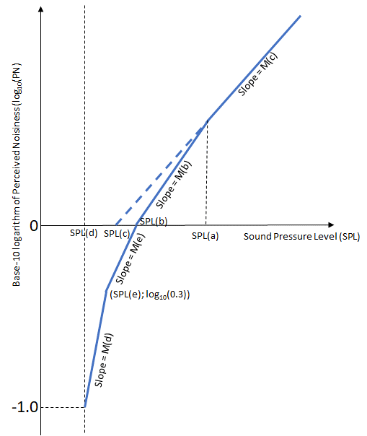

Figure : Perceived Noisiness as a function of Sound Pressure Level

|  |  |  |  |  |  |  |  |  |  |  |  |
| --- | --- | --- | --- | --- | --- | --- | --- | --- | --- | --- | --- |
| BAND (l) | ISO  BAND | Frequency  [Hz] | SPL(a) | SPL(b) | SPL(c) | SPL(d) | SPL(e) | M(b) | M(c) | M(d) | M(e) |
| 1 | 17 | 50 | 91.0 | 64 | 52 | 49 | 55 | 0.043478 | 0.030103 | 0.079520 | 0.058098 |
| 2 | 18 | 63 | 85.9 | 60 | 51 | 44 | 51 | 0.040570 | 0.030103 | 0.068160 | 0.058098 |
| 3 | 19 | 80 | 87.3 | 56 | 49 | 39 | 46 | 0.036831 | 0.030103 | 0.068160 | 0.052288 |
| 4 | 20 | 100 | 79.0 | 53 | 47 | 34 | 42 | 0.036831 | 0.030103 | 0.059640 | 0.047534 |
| 5 | 21 | 125 | 79.8 | 51 | 46 | 30 | 39 | 0.035336 | 0.030103 | 0.053013 | 0.043573 |
| 6 | 22 | 160 | 76.0 | 48 | 45 | 27 | 36 | 0.033333 | 0.030103 | 0.053013 | 0.043573 |
| 7 | 23 | 200 | 74.0 | 46 | 43 | 24 | 33 | 0.033333 | 0.030103 | 0.053013 | 0.040221 |
| 8 | 24 | 250 | 74.9 | 44 | 42 | 21 | 30 | 0.032051 | 0.030103 | 0.053013 | 0.037349 |
| 9 | 25 | 315 | 94.6 | 42 | 41 | 18 | 27 | 0.030675 | 0.030103 | 0.053013 | 0.034859 |
| 10 | 26 | 400 | ∞ | 40 | 40 | 16 | 25 | 0.030103 | **🡨 Not applicable 🡪** | 0.053013 | 0.034859 |
| 11 | 27 | 500 | ∞ | 40 | 40 | 16 | 25 | 0.030103 | 0.053013 | 0.034859 |
| 12 | 28 | 630 | ∞ | 40 | 40 | 16 | 25 | 0.030103 | 0.053013 | 0.034859 |
| 13 | 29 | 800 | ∞ | 40 | 40 | 16 | 25 | 0.030103 | 0.053013 | 0.034859 |
| 14 | 30 | 1000 | ∞ | 40 | 40 | 16 | 25 | 0.030103 | 0.053013 | 0.034859 |
| 15 | 31 | 1250 | ∞ | 38 | 38 | 15 | 23 | 0.030103 | 0.059640 | 0.034859 |
| 16 | 32 | 1600 | ∞ | 34 | 34 | 12 | 21 | 0.029960 | 0.053013 | 0.040221 |
| 17 | 33 | 2000 | ∞ | 32 | 32 | 9 | 18 | 0.029960 | 0.053013 | 0.037349 |
| 18 | 34 | 2500 | ∞ | 30 | 30 | 5 | 15 | 0.029960 | 0.047712 | 0.034859 |
| 19 | 35 | 3150 | ∞ | 29 | 29 | 4 | 14 | 0.029960 | 0.047712 | 0.034859 |
| 20 | 36 | 4000 | ∞ | 29 | 29 | 5 | 14 | 0.029960 | 0.053013 | 0.034859 |
| 21 | 37 | 5000 | ∞ | 30 | 30 | 6 | 15 | 0.029960 | 0.053013 | 0.034859 |
| 22 | 38 | 6300 | ∞ | 31 | 31 | 10 | 17 | 0.029960 | 0.029960 | 0.068160 | 0.037349 |
| 23 | 39 | 8000 | 44.3 | 37 | 34 | 17 | 23 | 0.042285 | 0.029960 | 0.079520 | 0.037349 |
| 24 | 40 | 10000 | 50.7 | 41 | 37 | 21 | 29 | 0.042285 | 0.029960 | 0.059640 | 0.043573 |

Table : Constants for mathematically formulated noy values

MoC1 NVTOL-TILT.1105 - Calculation of Effective Perceived Noise Level

**TONE CORRECTION FACTOR**

Paragraph “(c)” of “NVTOL-TILT.1105 - Calculation of Effective Perceived Noise Level” specifies how to calculate the tone correction factor. Additionally, for any lth one-third octave band, at any kth increment of time, for which the tone correction factor is suspected to result from something other than (or in addition to) an actual tone (or any spectral irregularity other than noise generated by the aircraft), an additional analysis may be made using a filter with a bandwidth narrower than one-third of an octave. If the narrow band analysis corroborates these suspicions, then a revised value for the “new broadband sound pressure level” of Step 4 in paragraph “(c)” of “NVTOL-TILT.1105 - Calculation of Effective Perceived Noise Level”, SPL'(l,k), should be determined from the narrow band analysis and used to compute a revised tone correction factor for that particular one-third octave band.

IM1 NVTOL-TILT.1105 - Calculation of Effective Perceived Noise Level

**NOISE DURATION**

Figure 2 provides an example to illustrate the selection of the first and last 10 dB-down points, kF and kL, specified in paragraph “(e)(1)” of “NVTOL-TILT.1105 - Calculation of Effective Perceived Noise Level”.

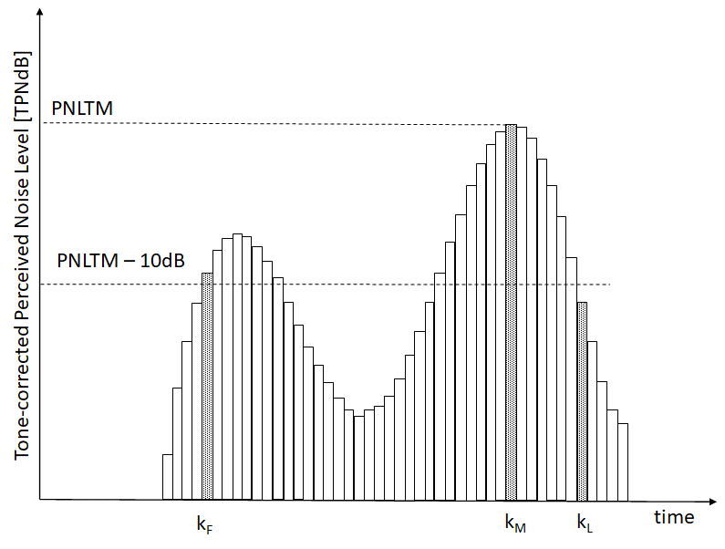

Figure : Example of a noise time history

## NVTOL-TILT.1110 - Calculation of A-weighted equivalent continuous sound pressure level

The A-weighted equivalent continuous sound pressure level, LAeq, is defined as the level, in dB(A), of the time integral of squared A-weighted sound pressure, pA, over a given time period, with reference to the square of the standard reference sound pressure, p0, of 20 μPa, and a reference duration of 30 seconds.

This metric is calculated by the following equation:

$$L_{Aeq}=10.\log_{10}\frac{1}{t_{M}}\sum_{k=1}^{N}{{\sum_{l=1}^{24}{ }10}^{0.1{SPL}_{AS}(l,k)}∆t}$$

where:

* SPLAS(l,k) is the time varying A-frequency-weighted SLOW-time-weighted one-third-octave-band sound pressure level in dB(A) measured at the kth instant of time in the lth one-third octave frequency band. Specifications for one-third octave band filters are specified in “NVTOL-TILT.1515 - Analysis system”;
* N is the last increment of k corresponding to the duration of tM=30 seconds;
* Δt is the time increment between samples; and
* The A-frequency weighting correction curve is defined in the IEC 61672-1 (“Electroacoustics — Sound level meters — Part I: Specifications”, 2013).

SUBPART C - REFERENCE CONDITIONS AND PROCEDURES

## NVTOL-TILT.1200 - Reference noise measurement points

1. For the take-off reference procedure,
   1. the central reference noise measurement point is located on the ground, vertically below the flight path defined in the take-off reference procedure of “NVTOL-TILT.1205 - Reference procedures” and 500 m horizontally in the direction of flight from the point at which transition to climbing flight is initiated.
   2. two lateral reference measurement points are located on the ground symmetrically disposed at 150 m on both sides of the flight path defined in the take-off reference procedure “NVTOL-TILT.1205 - Reference procedures” and lying on a line through the central reference noise measurement point.
2. For the overflight reference procedures,
   1. the central reference noise measurement point is located on the ground, vertically below the flight path defined in the overflight reference procedures of “NVTOL-TILT.1205 - Reference procedures” and 150 m vertically below the flight path defined in the overflight reference procedures.
   2. two lateral reference measurement points are located on the ground symmetrically disposed at 150 m on both sides of the flight path defined in the overflight reference procedures “NVTOL-TILT.1205 - Reference procedures” and lying on a line through the central reference noise measurement point.
3. For the approach reference procedure,
   1. the central reference noise measurement point is located on the ground, vertically below the flight path defined in the approach reference procedure of “NVTOL-TILT.1205 - Reference procedures” and 120 m vertically below the flight path defined in the approach reference procedure.
   2. two lateral reference measurement points are located on the ground symmetrically disposed at 150 m on both sides of the flight path defined in the approach reference procedure “NVTOL-TILT.1205 - Reference procedures” and lying on a line through the central reference noise measurement point.
4. For the hover reference procedure, an array of nine reference noise measurement points is defined as follows:
   1. one central reference noise measurement at the origin of the measurement array, which is defined on the ground, vertically below the stationary flight path specified in the hover reference procedure of “NVTOL-TILT.1205 - Reference procedures”.
   2. a first set of two reference noise measurement points is located on the ground, aligned in the same direction, at distances of 0.58 x H and 1.73 x H from the origin of the measurement array, where H=25 m.
   3. Three other sets of two reference noise measurement points each are located on the ground by rotating the first set of reference noise measurement points respectively by 90°, 180° and 270° about the normal from the ground at the origin of the measurement array.

IM1 NVTOL-TILT.1200 - Reference noise measurement points

**HOVER REFERENCE NOISE MEASUREMENT POINT**

Figure 3 and Figure 4 depict the arrangement of the 9 reference noise measurement points of the hover procedure. The arrangement of inverted microphone over a ground plate is specified in paragraph “(b)” of “NVTOL-TILT.1505 - Microphone system characteristics and set-up”. Alternatively, for logistical reasons, a setup with only three aligned microphones might be considered according to the depiction of Figure 3, where the applicant would then acquire three times more test points whereby the heading of the aircraft is rotated by steps of 90° about the normal from the ground at the origin of the measurement array.

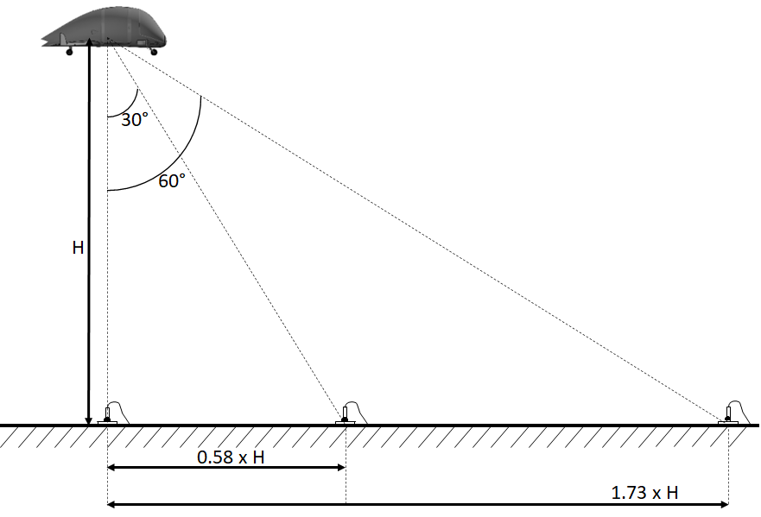

Figure : side view of the reference noise measurement points of the hover procedure

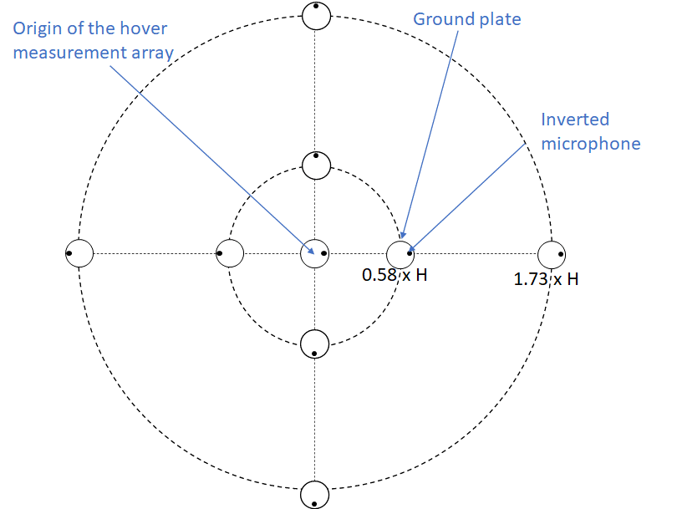

Figure : top view of the reference noise measurement points of the hover procedure

## NVTOL-TILT.1205 - Reference procedures

1. For the reference procedures specified in paragraphs “(c)”, “(d)”, “(e)” and “(f)”, the noise levels are determined under the reference atmospheric conditions defined in “NVTOL-TILT.1210 - Reference atmospheric conditions”.
2. In the reference procedures specified in paragraphs “(c)”, “(d)”, “(e)” and “(f)”, the point on the aircraft to use for the purpose of positioning the vehicle with respect to the reference noise measurement points is specified as follows:
   1. On the horizontal plane, the “centre of the smallest enclosing circle” as defined in Subpart B, MOC VTOL.2105, Section 8 of the Second Publication of Proposed Means of Compliance with the Special Condition VTOL, and depicted in Figure 5. If the aircraft dimensions vary between take-off, landing, or hover configurations, then the position of the centre of the smallest enclosing circle as well as diameter ‘D’ should be determined for each reference procedure.
   2. On the vertical plane, the vertical position of the centre of gravity.

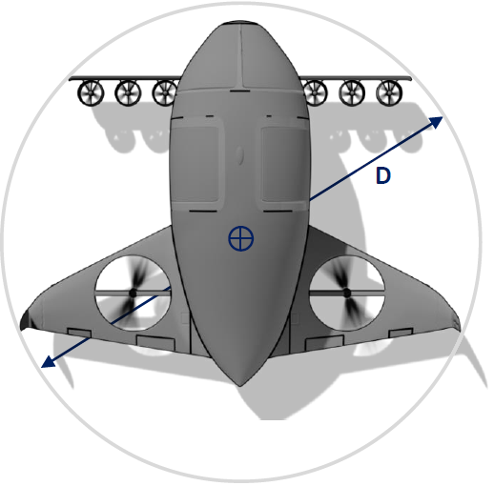

Figure : position of the centre of the smallest enclosing circle and associated diameter ‘D’ of the smallest enclosing circle.

1. The take-off reference procedure is defined as follows:
   1. the take-off profile is defined for a flat terrain throughout the entire flight path;
   2. the aircraft is stabilized at the power for maximum climb rate with the batteries at maximum State of Charge in the reference atmospheric condition specified in “NVTOL-TILT.1210 - Reference atmospheric conditions” along a path starting from a point located 500 m prior to the take-off central reference noise measurement point defined in paragraph “(a)” of “NVTOL-TILT.1200 - Reference noise measurement points”, at 20 m above the ground;
   3. the nacelle angle and the corresponding best rate of climb speed, Vy, or the lowest approved speed for the climb after take-off, whichever is the greater, is maintained throughout the take-off reference procedure;
   4. the mass of the aircraft is the maximum take-off mass at which certification is requested; and
   5. the reference take-off path is defined as a straight-line segment inclined from the starting point (500 m prior to the centre microphone location and 20 m above ground level) at an angle defined by best rate of climb and Vy corresponding to the selected nacelle angle for minimum individual specification engine performance.
2. The overflight reference procedures are subdivided into VTOL/conversion mode and aeroplane mode, and are defined as follows:
   1. For both VTOL/conversion mode and aeroplane mode procedures:
      1. the overflight profile is defined for a flat terrain throughout the entire flight path;
      2. the aircraft is stabilized in level flight overhead the overflight central reference noise measurement point defined in paragraph “(b)” of “NVTOL-TILT.1200 - Reference noise measurement points” at a height of 150 m;
      3. the mass of the aircraft is the maximum take-off mass at which certification is requested.
   2. For the VTOL/conversion mode procedure:
      1. the nacelle angle is maintained closest to the lowest nacelle angle certificated for zero airspeed; and
      2. a speed of 0.9 VCON is maintained throughout the overflight reference procedure;
   3. For the aeroplane mode procedure:
      1. the nacelle angle is maintained throughout the overflight reference procedure near 0°, in line with the longitudinal axis of the aircraft; and
      2. a speed of 0.9 VMCP or 0.9 VMO, whichever is lesser, is maintained throughout the overflight reference procedure.
3. The approach reference procedure is defined as follows:
   1. the approach profile is defined for a flat terrain throughout the entire flight path;
   2. the aircraft is stabilized and following a 6.0° approach path passing above the central reference noise measurement point defined in paragraph “(c)” of “NVTOL-TILT.1200 - Reference noise measurement points” at a height of 120 m;
   3. the approach is made at a stabilized airspeed equal to the best rate of climb speed corresponding to the nacelle angle, or the lowest approved speed for the approach, whichever is the greater, with power stabilized during the approach and over the flight path reference point, and continued throughout the entire 10 dB downpoint history;
   4. the mass of the aircraft at touchdown is the maximum landing mass at which certification is requested.
4. The hover reference procedure is defined as follows:
   1. the aircraft is stabilized in a stationary flight directly above the origin of the measurement array specified in paragraph “(d)(1)” of “NVTOL-TILT.1200 - Reference noise measurement points” at the reference height of 25 m;
   2. the aircraft is set to its MTOM.
5. When the applicant demonstrates that the design characteristics of the aircraft would prevent conducting the flight in accordance with the reference procedures defined in paragraphs “(c)”, “(d)”, “(e)”, or “(f)”, those procedures should:
   1. only depart from the reference procedures to the extent demanded by those design characteristics which make satisfying the reference procedures impossible;
   2. be agreed with the Agency.
6. For all reference procedures specified in “(c)”, “(d)”, “(e)”, and “(f)”, if the design allows for combinations of different rpm values between rotors, nacelle anlges, aircraft attitudes, control surfaces, or external appendages, whilst satisfying the requirements set forth in “(c)”, “(d)”, “(e)”, and “(f)”, the noisiest configuration must be identified and agreed with the Agency.

## NVTOL-TILT.1210 - Reference atmospheric conditions

The reference atmospheric conditions for the reference procedures defined in “NVTOL-TILT.1205 - Reference procedures” are defined as follows:

1. constant sea level atmospheric pressure of 1,013.25 hPa;
2. constant ambient air temperature of 25°C;
3. constant relative humidity of 70 per cent;
4. zero wind.

SUBPART D - MAXIMUM ALLOWABLE NOISE LEVELS

For the take-off reference procedure, the maximum value for EPNLTOref, specified in paragraph “(c)(1)” of “NVTOL-TILT.1605 - Satisfying maximum allowable noise levels”, is set at 106 EPNdB for the aircraft with maximum certificated take-off mass of 80,000 kg and over, and decreasing linearly with the base-10 logarithm of the aircraft maximum certificated take-off mass at a rate of 3 EPNdB per halving of mass down to 86 EPNdB, after which the limit is constant.

For the overflight reference procedures, both in VTOL/conversion and aeroplane modes, the maximum value of EPNLOVconv,ref and EPNLOVaero,ref, specified in paragraph “(d)(1)” of “NVTOL-TILT.1605 - Satisfying maximum allowable noise levels”, is set at 104 EPNdB for the aircraft with maximum certificated take-off mass of 80,000 kg and over, and decreasing linearly with the base-10 logarithm of the aircraft maximum certificated take-off mass at a rate of 3 EPNdB per halving of mass down to 84 EPNdB, after which the limit is constant.

For the approach reference procedure, the maximum value of EPNLAPref, specified in paragraph “(f)(1)” of “NVTOL-TILT.1605 - Satisfying maximum allowable noise levels”, is set at 109 EPNdB for the aircraft with maximum certificated take-off mass of 80,000 kg and over, and decreasing linearly with the base-10 logarithm of the aircraft maximum certificated take-off mass at a rate of 3 EPNdB per halving of mass down to 89 EPNdB, after which the limit is constant.

For the hover procedure adjustments specified in paragraph “(g)” of “NVTOL-TILT.1605 - Satisfying maximum allowable noise levels”, there is no maximum noise level.

IM1 SUBPART D Maximum Allowable Noise Levels

Table 3 summarises the maximum allowable noise levels of the aircraft specified in Subpart D.

|  |  |  |  |
| --- | --- | --- | --- |
| M = Maximum take-off  mass in 1 000 kg 0 0.788 80.0 | | | |
| Take-off noise level (EPNdB) | 86 | 87.0314 + 9.9673 log10 M | 106 |
| Overflight noise level (EPNdB) | 84 | 85.0314 + 9.9673 log10 M | 104 |
| Approach noise level (EPNdB) | 89 | 90.0314 + 9.9673 log10 M | 109 |

Table : Maximum allowable noise levels of the aircraft as a function of MTOM

SUBPART E - NOISE TEST

## NVTOL-TILT.1400 - Test environment conditions

1. For the take-off, overflight and approach procedures specified respectively in paragraphs “(c)”, “(d)” and “(e)” of “NVTOL-TILT.1205 - Reference procedures”, three noise measurement points are set up at the locations of the three reference noise measurements points specified in paragraphs “(a)”, “(b)” and “(c)” of “NVTOL-TILT.1200 - Reference noise measurement points” respectively (one central and two lateral points).
2. For the hover procedure specified in paragraph “(f)” of “NVTOL-TILT.1205 - Reference procedures”, nine noise measurement points are set up at the locations specified in paragraph “(d)” of “NVTOL-TILT.1200 - Reference noise measurement points”.
3. The noise measurement points should be located on a flat terrain having no excessive sound absorption characteristics.
4. If the noise measurement points are located on grass, the grass should be mowed below 8 cm of height on a minimum radius of 7.5 m around every noise measurement point.
5. If snow is present on the test site area, it should be completely cleared on a minimum radius of 15 m around every noise measurement point. Additionally, snow should not be piled up at the borders of this cleared area.
6. The conical space above each noise measurement point defined by an axis normal to the ground and by a half-angle of 80° from this axis should be free of obstructions that could influence the propagation of noise between aircraft and microphones.
7. The temperature, the relative humidity, the wind speed and direction and the atmospheric pressure should be measured for each run:
   1. at a height of 10 m above the ground level;
   2. within 2,000 m of the central microphone location defined in paragraph “(a)”;
   3. temperature and relative humidity should be measured within 30 seconds of the aircraft flight across the microphone line for the take-off, overflight and approach procedures specified in paragraphs “(c)”, “(d)” and “(e)” of “NVTOL-TILT.1205 - Reference procedures”, and within 30 seconds of the beginning or end of the hover noise measurement for the procedure specified in paragraph “(f)” of “NVTOL-TILT.1205 - Reference procedures”.
   4. the wind speed and direction should be measured at a sample rate of at least 2 Hz during all noise measurements.
8. The meteorological instruments should be operated within their environmental limitations as specified by their manufacturer.
9. The requested accuracy of the temperature, relative humidity and wind sensors should be equal to or better than the following values:
   1. ±0.5°C for the temperature;
   2. ±3% for the relative humidity or ±0.5°C for both the dry bulb and the dew point temperatures when the relative humidity is measured with a psychrometer;
   3. ±0.3 m/s and ±3° for the wind strength and direction respectively.
10. The test should be carried out under the following atmospheric conditions:
    1. no precipitation;
    2. the ambient air temperature should not be greater than 35°C and should not be less than -10°C over the sound propagation path between a point 10 m above the ground and the aircraft;
    3. the relative humidity should not be greater than 95 per cent and should not be less than 20 per cent over the sound propagation path between a point 10 m above the ground and the aircraft;
    4. the value of atmospheric absorption of sound in the 8 kHz one-third octave band, determined according to the procedure specified in “MoC2” at 10 m above the ground, should not exceed 14 dB/100 m at the PNLTM of each test run;
    5. the 30-second average wind speed, measured at 10 m above the ground, should not exceed:
       1. 5.1 m/s (10 kt) for the take-off, overflight and approach procedures specified respectively in paragraphs “(c)”, “(d)” and “(e)” of “NVTOL-TILT.1205 - Reference procedures”, where the 30-second average wind speed measurement is centered on the time of aircraft crossing the line of the three noise measurement points specified in paragraph “(a)";
       2. 2.6 m/s (5 kt) for the Hover procedure specified in paragraph “(f)” of “NVTOL-TILT.1205 - Reference procedures”, where the 30-second average is obtained coincidently with the 30-second hover noise recording;
    6. the crosswind component of the average wind speed specified in paragraph “(5)” should not exceed 2.6 m/s (5 kt) for the take-off, overflight and approach procedures specified respectively in paragraphs “(c)”, “(d)”, and “(e)” of “NVTOL-TILT.1205 - Reference procedures”; and
    7. there should not be any anomalous meteorological or wind conditions that would significantly affect the measured noise levels. In particular, there should not be any temperature inversion equal or larger than 2°C during any test run (where a temperature inversion is defined as a positive difference between temperature at the aircraft location minus ambient air temperature at 10 m).

MoC1 NVTOL-TILT.1400 - Test environment conditions

**METEOROLOGICAL INSTRUMENTS**

The temperature can be measured with a temperature sensor that meets the tolerance Class B specifications of IEC 60751 (“Industrial platinum resistance thermometers and platinum temperature sensors”, 2nd edition, July 2008). The accuracy of such a sensor is equal to or better than ±0.5°C.

MoC2 NVTOL-TILT.1400 - Test environment conditions

**DETERMINATION OF COEFFICIENTS OF ATMOSPHERIC ABSORPTION OF SOUND**

The reduction in level of sound within the lth one-third octave band, α(l), in dB per 100 metres, due to the effects of atmospheric absorption of sound, is determined from the following equation:

α(l) = 10[2.05 log10 (fo/1 000) + 1.1394 × 10-3θ - 1.916984] + η(δ) × 10[log10 (fo) + 8.42994 × 10-3θ - 2.755624]

where $δ=\sqrt{\frac{1010}{f_{o}}}$ 10(log10 RH - 1.328924 + 3.179768 × 10-2θ) × 10(-2.173716 × 10-4θ2 + 1.7496 × 10-6θ3)

θ is the temperature in °C and RH is the relative humidity expressed as a percentage. They are obtained from the specifications of paragraph “(g)” of “NVTOL-TILT.1400 - Test environment conditions”. The values of η(δ) and f0 are provided respectively in Table 4 and Table 5. The values of η(δ) are determined from Table 4 through quadratic interpolation.

|  |  |  |  |
| --- | --- | --- | --- |
| δ | η(δ) | δ | η(δ) |
| 0.00 | 0.000 | 2.50 | 0.450 |
| 0.25 | 0.315 | 2.80 | 0.400 |
| 0.50 | 0.700 | 3.00 | 0.370 |
| 0.60 | 0.840 | 3.30 | 0.330 |
| 0.70 | 0.930 | 3.60 | 0.300 |
| 0.80 | 0.975 | 4.15 | 0.260 |
| 0.90 | 0.996 | 4.45 | 0.245 |
| 1.00 | 1.000 | 4.80 | 0.230 |
| 1.10 | 0.970 | 5.25 | 0.220 |
| 1.20 | 0.900 | 5.70 | 0.210 |
| 1.30 | 0.840 | 6.05 | 0.205 |
| 1.50 | 0.750 | 6.50 | 0.200 |
| 1.70 | 0.670 | 7.00 | 0.200 |
| 2.00 | 0.570 | 10.00 | 0.200 |
| 2.30 | 0.495 |  |  |

Table : Values of η(δ)

|  |  |  |  |
| --- | --- | --- | --- |
| *Centre frequency*  *of the 1/3*  *octave band*  *[Hz]* | *fo*  *[Hz]* | *Centre frequency*  *of the 1/3*  *octave band*  *[Hz]* | *fo*  *[Hz]* |
| 50 | 50 | 800 | 800 |
| 63 | 63 | 1 000 | 1 000 |
| 80 | 80 | 1 250 | 1 250 |
| 100 | 100 | 1 600 | 1 600 |
| 125 | 125 | 2 000 | 2 000 |
| 160 | 160 | 2 500 | 2 500 |
| 200 | 200 | 3 150 | 3 150 |
| 250 | 250 | 4 000 | 4 000 |
| 315 | 315 | 5 000 | 4 500 |
| 400 | 400 | 6 300 | 5 600 |
| 500 | 500 | 8 000 | 7 100 |
| 630 | 630 | 10 000 | 9 000 |

Table : Values of f0

IM1 NVTOL-TILT.1400 - Test environment conditions

**NOISE MEASUREMENT CONDITIONS**

Thick, matted, tall grass, shrubs, or wooded areas are terrains that absorb sound excessively and should be avoided. In addition, people who carry out the measurements should avoid constituting an obstruction that influences the sound measurement.

IM2 NVTOL-TILT.1400 - Test environment conditions

**ALLOWABLE WIND SPEEDS**

The wind speed restrictions specified in paragraphs “(5)” and “(6)” contribute to the repeatability of the noise levels between all runs. For the sake of simplicity, those restrictions are based on average wind speeds and do not specify any requirement regarding instant wind speeds. Nevertheless, wind gusts can be the cause of repeatability issues, as they might induce automatic rpm or positioning corrections from the aircraft. With agreement of the Agency, when testing under wind gusts conditions, if any significant rotor rpm adjustment (e.g.: spool-up or spool-down) is detected, or if any automated spatial adjustment of the aircraft is observed, the test run should be rejected and repeated.

## NVTOL-TILT.1405 - Flight test procedures

1. The aircraft used for the test should conform to its production design. Any deviation of the test aircraft to its production design regarding components or features that might affect its noise characteristics should be accepted by the Agency.
2. The aircraft is set to its MTOM or above for the start of the test. If the aircraft design leads to a mass decrease as the test progresses, any test run where the mass of the aircraft is lower than 90 percent of its MTOM should be rejected.
3. For the take-off procedure:
   1. a minimum of six valid runs should be acquired;
   2. the true airspeed should not vary from the reference airspeed appropriate to the flight demonstration by more than ±9 km/h (±5 kt) throughout the 10 dB-down period;
   3. prior to the execution of the take-off procedure, the applicant should establish, in agreement with the Agency, a targeted take-off test height above the central noise measurement point specified in paragraph “(a)” of “NVTOL-TILT.1400 - Test environment conditions”. This targeted take-off test height should be within +15 m, -110 m, of the reference height above the central noise reference point specified in paragraph “(c)” of “NVTOL-TILT.1205 - Reference procedures”. During the execution of the take-off test procedure, the aircraft height above the central noise measurement point should be within ±10% of the targeted take-off test height, and remain higher than two times the diameter ‘D’ of smallest enclosing circle as defined in paragraph “(b)(1)” of “NVTOL-TILT.1205 - Reference procedures”;
   4. the aircraft should fly within ±10° or ±20 m, whichever is greater, from the vertical above the reference path projection throughout the 10 dB-down period; and
   5. the rpm of each individual rotor should not vary from its average value by more than ±3% during the 10 dB-down period.
4. For each overflight procedure (VTOL/conversion mode and aeroplane mode):
   1. a minimum of six valid runs should be acquired, with the number of valid runs made with a headwind component equal to the number of valid runs made with a tailwind component, and the test runs should be conducted in pairs of opposite flight direction;
   2. the true airspeed should not vary from the reference airspeed appropriate to the flight demonstration by more than ±9 km/h (±5 kt) throughout the 10 dB-down period;
   3. prior to the execution of each overflight procedure, the applicant should establish, in agreement with the Agency, a targeted overflight test height above the central noise measurement point specified in paragraph “(a)” of “NVTOL-TILT.1400 - Test environment conditions”. This targeted overflight test height should be within +15 m, -110 m, of the reference height above the central noise reference point specified in paragraph “(d)” of “NVTOL-TILT.1205 - Reference procedures”. During the execution of each overflight test procedure, the aircraft height above the central noise measurement point should be within ±10% of the targeted overflight test height, and remain higher than two times the diameter ‘D’ of smallest enclosing circle as defined in paragraph “(b)(1)” of “NVTOL-TILT.1205 - Reference procedures”;
   4. the aircraft should fly within ±10° or ±20 m, whichever is greater, from the vertical above the reference path projection throughout the 10 dB-down period; and
   5. the rpm of each individual rotor should not vary from its average value by more than ±3% during the 10 dB-down period.
5. For the approach procedure:
   1. a minimum of six valid runs should be acquired;
   2. the true airspeed should not vary from the reference airspeed specified in paragraph “(d)(1)(iii)” of “NVTOL-TILT.1205 - Reference procedures” by more than ±9 km/h (±5 kt) throughout the 10 dB-down period;
   3. prior to the execution of the approach procedure, the applicant should establish, in agreement with the Agency, a targeted approach test height above the central noise measurement point specified in paragraph “(a)” of “NVTOL-TILT.1400 - Test environment conditions”. This targeted approach test height should be within +15 m, -80 m, of the reference height above the central noise reference point specified in paragraph “(e)” of “NVTOL-TILT.1205 - Reference procedures”. During the execution of the approach test procedure, the aircraft height above the central noise measurement point should be within ±10% of the targeted approach test height, and remain higher than two times the diameter ‘D’ of smallest enclosing circle as defined in paragraph “(b)(1)” of “NVTOL-TILT.1205 - Reference procedures”;
   4. the aircraft flight path should remain between 5.5° and 6.5° descent angles throughout the 10 dB-down period;
   5. the aircraft should fly within ±10° or ±20 m, whichever is greater, from the vertical above the reference path projection throughout the 10 dB-down period; and
   6. the rpm of each individual rotor should not vary from its average value by more than ±3% during the 10 dB-down period.
6. For the hover procedure:
   1. a minimum of six runs should be performed;
   2. the aircraft should be set to maintain a stabilized hovering position during 30 seconds at the vertical above the noise measurement point;
   3. prior to the execution of the hover procedure, the applicant should establish, in agreement with the Agency, a targeted hover test height above the centre noise measurement point. This targeted hover test height should be between 12 m and 50 m;
   4. the aircraft should always remain within a 3° cone from the vertical above the noise measurement point during the 30 seconds of noise recording;
   5. the aircraft height above the centre noise measurement point always needs to be within ±1 m of the targeted hover test height specified in paragraph “(3)” and to remain higher than two times the diameter ‘D’ of smallest enclosing circle as defined in paragraph “(b)(1)” of “NVTOL-TILT.1205 - Reference procedures”. Additionally, the downwash of the aircraft cannot impinge the microphones; and
   6. the aircraft should be flown outside of the conditions specified in paragraphs “(4)” and “(5)” and flown back in condition between each run.
7. When the applicant demonstrates that the design characteristics of the aircraft would prevent conducting the flight in accordance with the flight test procedures defined in paragraphs “(c)”, “(d)”, “(e)”, and “(f)”, those procedures should:
   1. only depart from the test procedures to the extent demanded by those design characteristics which make satisfying the test procedures impossible;
   2. be agreed with the Agency.
8. For each run of the take-off, overflight and approach procedures, the background noise levels, when analysed in the same way and expressed in PNL (as specified in paragraph “(b)” of “NVTOL-TILT.1105 - Calculation of Effective Perceived Noise Level”), should be at least 20 PNdB below the maximum PNL of the aircraft. For each run of the hover procedure, the aircraft maximum A-frequency-weighted sound level (LAmax) should be greater than the background noise A-weighted sound level by at least 15 dB(A). Any test run for which this condition is not satisfied should be invalidated.
9. If the condition specified in paragraph “(h)” cannot be fulfilled, the targeted test heights should be adapted whilst remaining within the allowable height tolerances specified in paragraphs “(c)(3)”, “(d)(3)”, “(e)(3)” respectively for the take-off, overflight, approach procedures, and in paragraphs “(f)(3)” and “(f)(5)” for the hover procedure, or an alternative test site should be chosen to ensure appropriate noise measurements.
10. Additionally, the applicant should consider source noise adjustments (Δ3) specified in paragraph “(b)(9)” of “NVTOL-TILT.1600 - Adjustments of the measured sound levels” and therefore conduct additional testing to develop at least sensitivity curves of EPNL versus True Airspeed (TAS), or PNLTM versus TAS, or PNLT versus TAS. This demands testing at different flight speeds around the reference flight speed.
11. A sufficient number of runs should be performed to ensure that the 90 per cent confidence intervals of the reference sound levels are within EPNLTOref ±1.5 EPNdB, EPNLOvref ±1.5 EPNdB, EPNLApref ±1.5 EPNdB, and LAeqref_av ±1.5 dB(A) respectively for the take-off, overflight, approach and hover reference procedures and to ensure that the test is valid as specified in paragraph “(b)” of “NVTOL-TILT.1605 - Satisfying maximum allowable noise levels”.

MoC1 NVTOL-TILT.1405 - Flight test procedures

**TEST HEIGHT AND SPEED**

1. Differences between aircraft test and reference profiles are adjusted as specified in Subpart G for the difference in sound propagation path lengths (spherical spreading and atmospheric absorption effects), for the difference in the noise event durations, and for differences in source generation mechanisms. To minimise these adjustments, for the three measurement procedures specified in paragraphs “(c)”, “(d)” and “(e)” of “NVTOL-TILT.1405 - Flight test procedures”, the targeted test airspeed should be set as close as possible to the reference airspeed, and for all four measurement procedures of “NVTOL-TILT.1405 - Flight test procedures”, the targeted test heights specified in paragraphs “(c)(3)”, “(d)(3)”, “(e)(3)” and “(f)(3)” of “NVTOL-TILT.1405 - Flight test procedures” should be set by default as close as possible to the reference heights of the corresponding reference procedures.
2. However, those targeted test heights may not be achievable due to excessive background noise and prevent the specification of paragraph “(h)” of “NVTOL-TILT.1405 - Flight test procedures” to be satisfied.

One possible means to overcome this issue is, for a given test procedure, to lower the targeted test height until the criterion of paragraph “(h)” of “NVTOL-TILT.1405 - Flight test procedures” can be met for each run (while remaining in the allowable height tolerances specified in paragraphs “(c)(3)”, “(d)(3)”, “(e)(3)” and “(f)(3)” respectively for the take-off, overflight, approach and hover procedures, and as long as the aircraft is flown within its allowable operational range based on its design and the local restrictions at the test site). To adapt and determine the appropriate targeted test height, practice runs (not valid for the establishment of noise levels) should be conducted in the configuration as specified in Subpart E. Since variations in measured sound levels of up to ±2.0 EPNdB or ±2.0 dB(A) may occur from run to run, the difference between the aircraft sound level and background noise sound level should therefore be large enough to accommodate the anticipated quietest aircraft sound level.

When setting a targeted test height different than the reference height, the two lateral stations should be relocated to maintain similar noise elevation angle (“Ψ”) as with the reference height, as depicted in Figure 6 for the take-off, overflight and approach procedures. For the test hover procedure, if setting a targeted test height different from 25 m, the microphones depicted on Figure 4 should also be relocated accordingly.

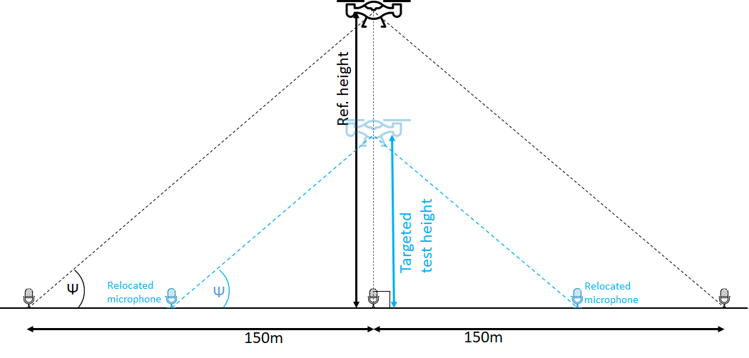

Figure : Relocation of the lateral microphone to maintain noise elevation angles when changing targeted test height

For the take-off, overflight and approach measurement procedures specified in paragraphs “(c)”, “(d)” and “(e)”, the targeted test heights should also be established with consideration for limiting the angular velocity (variation of emission angle per second, where the emission angle θ is depicted on Figure 8, Figure 9, and Figure 10) over the 10 dB downpoint of each run. A low targeted test height combined with a rather fast flying speed can result in loss of noise signature information since paragraph “(a)(2)” of “NVTOL-TILT.1105 - Calculation of Effective Perceived Noise Level” require sound levels to be sampled every half-second. An angular velocity below 40° per second at all time within each test run 10 dB downpoint has already been accepted by the Agency for similar noise measurement procedures.

MoC2 NVTOL-TILT.1405 - Flight test procedures

**HOVER NOISE**

Figure 7 depicts the specified boundaries of the aircraft flight path for the hover reference procedure. Paragraph “(f)(6)” of “NVTOL-TILT.1405 - Flight test procedures” specifies that, after the 30-second noise recording of every run of the hover test procedure (valid or not), the aircraft be flown outside of the allowable window depicted in grey on Figure 7, which combines the ±1 m height window specified in paragraph “(f)(5)” of “NVTOL-TILT.1405 - Flight test procedures” and the 3°-cone specified in paragraph “(f)(4)” of “NVTOL-TILT.1405 - Flight test procedures”, before being flown back into condition and initiating the next 30-second noise recording. Under no circumstance can a continuous on-condition recording be performed and later be subdivided into 30-second recordings.

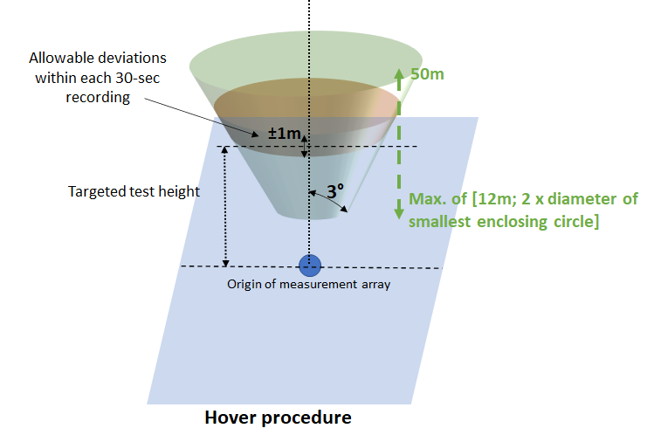

Figure : Depiction of allowable flight boundaries for the hover procedure

IM1 NVTOL-TILT.1405 - Flight test procedures

**NUMBER OF RUNS**

It may happen that some runs deemed valid during the test have to be rejected upon further analysis of the data. If, at the end of this phase, the number of valid runs is found to be lower than the specified minimum number of six, or the 90 per cent confidence interval is outside of EPNLTOref ±1.5 EPNdB, EPNLOVconv,ref ±1.5 EPNdB, EPNLOVaero,ref ±1.5 EPNdB, EPNLAPref±1.5 EPNdB, and LAeqref_av ±1.5 dB(A) respectively for the take-off, overflight in VTOL/conversion mode, overflight in aeroplane mode,, approach and hover reference procedures, more test runs will have to be performed to fulfil those conditions. It is therefore recommended during the test to conduct additional runs to mitigate the risk of having to deploy the complete test equipment again.

IM2 NVTOL-TILT.1405 - Flight test procedures

**TAKE-OFF FLIGHT TEST PROCEDURE**

1. Take-off profile

Figure 8 depicts the reference take-off profile and a possible measured take-off profile under zero-wind condition. The reference take-off profile is a straight-line segment. It starts from a defined point Cr that is 500 m from the centre noise measurement point (A) and at a height of 20 m above the ground. The reference climb angle γR of the straight-line path will depend on the certificated best rate of climb and Vy at the reference conditions. The reference profile ends at a point Ir which will encompass the 10 dB-down period of the noise measurements. The position of point L along the measured take-off path corresponds to the same value of emission angle θ as point Lr on the reference take-off path (θ = θr) for the adjustment procedure specified in paragraph “(b)(3)” of “NVTOL-TILT.1600 - Adjustments of the measured sound levels”. Figure 8 depicts the situation where θ = θr with respect to the centre noise measurement point (A), but a similar depiction, albeit with a different position of point L, would apply to the emission angles calculated with respect to the sideline noise measurement points (Sstarboard and Sport). The targeted test height overhead the centre noise measurement point (Heighttarget) has to be set within +15m, -110m of the overhead height on the reference profile (Heightref). The test height of the measured take-off flight path when crossing the [Sstarboard;Sport] segment (Heightmeas) has to be within ±10% of heighttarget.

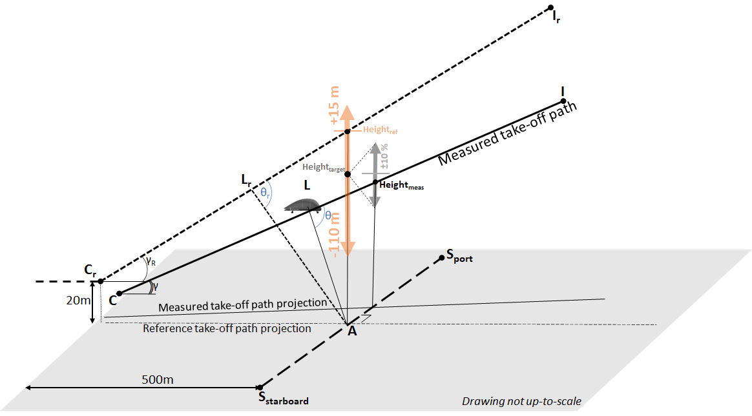

Figure : Depiction of measured and reference take-off profiles (not up-to-scale). Orange vertical arrow depicts allowable targeted test height tolerance. Grey vertical arrow depicts allowable deviation between actual test height and targeted test height.

The reference climb angle, γR, is based on the best rate of climb and Vy airspeed determined from approved manufacturer’s data for the take-off performance of the aircraft at the reference conditions. Since airspeed is defined as being in the direction of the flight path, the climb angle γ is the arcsine of the ratio of best rate of climb to Vy.

1. Flight test procedure
   1. Number of test runs

At least six valid test runs are needed with simultaneous noise measurements at each of the noise measurement points. Since it cannot be determined until the analysis is partly completed if each test run meets all the specifications of this document, the applicant will find merit in conducting additional take-off test runs. If additional test runs are conducted and more than six valid noise measurements are simultaneously obtained at all three measurement points, then the results of such test runs also should be included in the averaging process for calculating EPNL.

* 1. Horizontal and Vertical adjustment of climb initiation

In coordination with the Agency, Position C on Figure 8, or the height of the initial level flight may also be varied to fulfil the specification of paragraph “(h)” of “NVTOL-TILT.1405 - Flight test procedures”.

* 1. Practice flights

The applicant may find it helpful, if not essential, to conduct a number of practice or pre-noise evaluation test runs to adjust the height/location of Position C. With prior approval of the Agency, these practice runs can be excluded from the noise evaluation. These runs should also be documented in the noise evaluation report as practice flights.

* 1. Rotor speed

The specification for individual rotor speeds to remain within ±3% of their averaged value during the 10 dB-down period is intended to provide repeatability to the noise measurements. An alternative envelope for individual rpm variations can be proposed by the applicant in coordination with the Agency.

IM3 NVTOL-TILT.1405 - Flight test procedures

**OVERFLIGHT FLIGHT TEST PROCEDURES**

1. Overflight profile

Figure 9 depicts the reference overflight profile and a possible measured overflight profile under zero-wind condition, either for the VTOL/conversion mode or for the aeroplane mode.

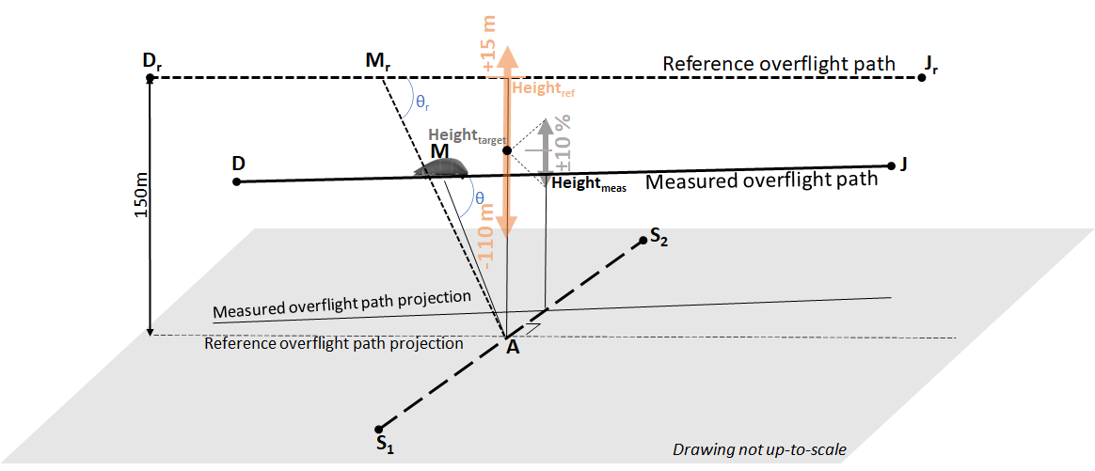

Figure : Depiction of measured and reference overflight profiles (not up-to-scale). Orange vertical arrow depicts allowable targeted test height tolerance. Grey vertical arrow depicts allowable deviation between actual test height and targeted test height.

1. Flight test procedure
   1. Flight path/height determination

The flight path should be “straight and level”. Since there is no specification for the terrain over which the aircraft is flying to be perfectly level, the height of the aircraft above the ground may vary slightly over the distance corresponding to the 10 dB-down period. Since paragraph “(d)” of “NVTOL-TILT.1415 - Spatial positioning and speed measurement” specifies the use of augmented DGNSS to track aircraft position, the flight path/height determination should account for the actual ground elevations at which the system components are placed.

* 1. Number of test runs

For each overflight procedure (VTOL/conversion mode and aeroplane mode), at least six valid overflight test runs are needed, with equal numbers with headwind and tailwind. Since the data will be adjusted, there are no specifications for these to be flown in pairs immediately one after the other. Conducting the test runs in pairs, however, would alleviate the need to take the wind direction into account. The applicant will therefore typically find it expedient to conduct tests in such a manner and include additional pairs of test runs in case any of the test runs are proved invalid on subsequent analysis.

* 1. Rotor speed

The specifications in paragraph “(d)(5)” of “NVTOL-TILT.1405 - Flight test procedures” for individual rotor speeds to remain within ±3% of their averaged value during the 10 dB-down period is intended to provide repeatability to the noise measurements. An alternative envelope for individual rpm variations can be proposed by the applicant and will need to be agreed with the Agency.

IM4 NVTOL-TILT.1405 - Flight test procedures

**APPROACH FLIGHT TEST PROCEDURE**

1. Approach profile

Figure 10 depicts the reference approach profile and a possible measured approach profile under zero-wind condition.

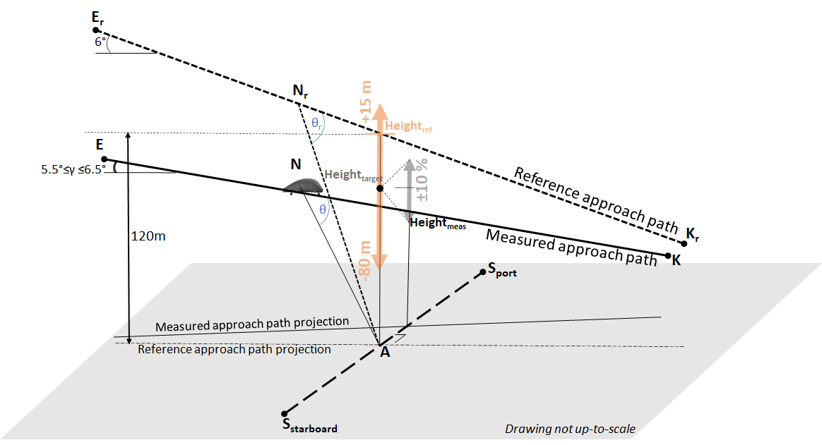

Figure : Depiction of measured and reference approach profiles (not up-to-scale). Orange vertical arrow depicts allowable targeted test height tolerance. Grey vertical arrow depicts allowable deviation between actual test height and targeted test height.

1. Flight test procedure
   1. Number of test runs

At least six valid test runs are needed with simultaneous noise measurements at each of the noise measurement points. The applicant should, as in the case of take-off and overflight, consider additional test runs to ensure that enough valid data points are available.

* 1. Rotor speed

The specification in paragraph “(e)(6)” of “NVTOL-TILT.1405 - Flight test procedures” for individual rotor speeds to remain within ±3% of their averaged value during the 10 dB-down period is intended to provide repeatability to the noise measurements. An alternative envelope for individual rpm variations can be proposed by the applicant and will need to be agreed with the Agency.

* 1. Flight path angle

The measured flight path descent angle γ needs to remain between 5.5° and 6.5°.

## NVTOL-TILT.1410 - Noise measurement

1. Noise measurement setup:
   1. The sound levels should be measured with a noise measurement system satisfying the specifications of Subpart F.
   2. The acoustical signals should be recorded and stored for subsequent analysis using a recording and reproducing system or computer-based system.
   3. Provision should be made for an overload indication to occur during an overload condition on any relevant level range. Aircraft noise data collected during an overload condition of any measurement system components in the signal path prior to and including the recorder are invalid and should not be used.
   4. The background noise should be recorded (for at least 30 seconds) at the measurement points with the system gain set at the levels used for the aircraft noise measurements. The recorded background noise should be representative of that which exists during the test run. Background noise recordings should be performed at the beginning and end of every test series, and at least every hour within a given test series.
   5. The entire noise measurement setup should be described, and all its individual components identified in a Test Plan to be reviewed and agreed by the Agency.
2. Calibration and checking of the system:
   1. The acoustical sensitivity of the noise measurement system should be checked for each group of aircraft noise measurements with the system gain set at levels which will be used for the noise measurements, using a sound calibrator as specified in paragraph “(a)” of “NVTOL-TILT.1520 - Calibration systems”, before the test starts, after the test has ended, and at regular intervals during the test. Aircraft noise data acquired not preceded and succeeded by such checks are invalidated. One necessary condition for the noise measurement system to be considered satisfactory is for the difference of acoustical sensitivity levels of the noise measurement system to be less than or equal to 0.5 dB(A) between the checks. The arithmetic average of the preceding and succeeding calibrations should be used to represent the acoustical sensitivity level of the measurement system for each group of aircraft noise measurements. The corresponding calibration corrections should be reported to the Agency as part of the reporting specifications of Subpart H and applied to all measured one-third octave band sound pressure levels determined from the output of the analyser as specified in paragraph “(a)(1)” of “NVTOL-TILT.1600 - Adjustments of the measured sound levels”.
   2. When the angles of incidence at the microphone of sound emitted from the aircraft are outside of ±30° of grazing incidence (see Figure 12), corrections for incidence effects should be determined at the angle of incidence for each one-half second sample.
   3. The insertion losses of windscreens should be determined for each one-third octave nominal mid-band frequency from 50 Hz to 10 kHz inclusive within six months of each aircraft noise measurement by a method traceable to a national standards laboratory with sinusoidal sound signals at appropriate incidence angles on the inserted microphone. With respect to windscreen insertion losses, the following specifications should be used:
      1. The change in insertion losses from the previous calibration at each one-third octave frequency band should not be more than ±0.4 dB, otherwise the windscreen should be replaced by a new one.
      2. In the absence of wind and for sinusoidal sounds at grazing incidence, the insertion loss caused by the windscreen of a stated type installed around the microphone should not exceed ±1.5 dB at nominal one-third octave mid-band frequencies from 50 Hz to 10 kHz inclusive.
   4. The frequency response of the entire measurement system, exclusive of the microphone and windscreen, but otherwise configured as deployed in the field during the aircraft noise measurements, should be established. Corrections should be determined for each one-third octave nominal mid-band frequency from 50 Hz to 10 kHz inclusive. The determination should be made at a level within 5 dB of the level corresponding to the calibration sound pressure level on the reference level range.

The frequency response of the entire measurement system should be determined either with pseudo-random noise or alternatively with discrete sine or swept sine signals at every third-octave mid-band from 50 Hz to 10 kHz. If a pink noise calibrator is used, it should be calibrated within 6 months of the measurement and its output in each one-third octave band should not change by more than 0.2 dB between calibrations. Should this condition not be met, the pink noise calibrator should not be used for the test and should be replaced. If the system frequency response corrections are determined away from the field, then frequency response testing should still be performed in the field to ensure the integrity of the measurement system.

1. The calibration corrections specified in paragraph “(b)”, including those for the environmental effects on sound calibrator output level, should be applied to the measured one third octave sound pressure levels determined from the output of the analyser.

MoC1 NVTOL-TILT.1410 - Noise measurement

**SOUND CALIBRATOR CHECKS**

The initial, final and periodic checks permit to identify any potential change in the overall sensitivity of the noise measurement system. It is important that the system warm-up time recommended by the noise measurement instruments manufacturer be observed prior to the checks.

MoC2 NVTOL-TILT.1410 - Noise measurement

**WINDSCREENS**

When windscreens are undamaged and uncontaminated, the insertion effects specified in paragraph “(b)(3)” of “NVTOL-TILT.1410 - Noise measurement” may be obtained directly from the manufacturer’s data. When the angles of incidence of sound emitted from an aircraft are within +30° of grazing incidence, a single set of values based upon windscreen insertion loss tests at grazing incidence may be used. For other cases, the windscreen insertion loss adjustments should be determined and applied on the basis of intervals between angles tested not exceeding 30°. When the windscreen data adjustments provided by the manufacturer are presented in the form of curves, the insertion loss throughout each one-third octave band, rather than just at the nominal mid-band frequency, should be included. Windscreen data adjustments may also be obtained by free-field calibration in an anechoic chamber if agreed with the Agency.

MoC3 NVTOL-TILT.1410 - Noise measurement

**APPLICATION OF ADJUSTMENTS FOR INCIDENCE**

To meet the specifications of paragraph “(b)(2)” of “NVTOL-TILT.1410 - Noise measurement”, provided that a continuous record of time-space-position information is available, free-field and windscreen insertion-loss incidence data adjustments can be applied to the noise data on a half-second record by half-second record basis. These adjustments are obtained by calculating the angle of incidence for each record, using the point of time that characterizes the 2-second averaging period of the SLOW time weighting (see “MoC2 NVTOL-TILT.1515 - Analysis system”) and determining the aircraft emission coordinates and angle of incidence for the sound measured at that time.

IM1 NVTOL-TILT.1410 - Noise measurement

**SOUND LEVEL VARIABILITY**

The measured sound level values may vary due to environmental factors and the internal warm-up as recommended for most noise measurement instruments. Occasionally, variations of measured sound level values may occur due to cable problems or even equipment damage. A proper check of the overall sensitivity of the noise measurement system permits to identify such occurrences.

## NVTOL-TILT.1415 - Spatial positioning and speed measurement

1. The point of the aircraft that is tracked for positioning should be carefully identified to ensure a consistent adjustment to the reference flight track specified in “NVTOL-TILT.1200 - Reference noise measurement points”.
2. For the take-off, overflight and approach procedures, and for each run, the following parameters should be measured or derived:
   1. the spatial coordinates of the aircraft in terms of latitude, longitude and height, or in a Cartesian coordinate system with its origin at the central measurement point defined in paragraphs “(a)”, “(b)” and “(c)” of “NVTOL-TILT.1200 - Reference noise measurement points”, the X axis aligned in the direction of the reference flight path projection, the Y axis towards the port direction and the Z axis pointing up. The spatial coordinates should be measured or derived with a sample rate equal to or greater than 2 Hz;
   2. the True Airspeed of the aircraft with a sample rate equal to or greater than 2 Hz;
   3. the values of each individual rotor rpm with a sample rate equal to or greater than 2 Hz;
   4. the values of each individual nacelle angle with a sample rate equal to or greater than 2 Hz.
3. For the hover procedure, and for each run, the following parameters should be measured or derived:
   1. the spatial coordinates of the aircraft in terms of latitude, longitude and height, or in a Cartesian coordinate system with its origin at the central measurement point specified in paragraph “(d)” of “NVTOL-TILT.1200 - Reference noise measurement points”, the X axis aligned in the direction of the first set of noise measurement points specified in paragraph “(d)(2)” of “NVTOL-TILT.1200 - Reference noise measurement points”, the Z axis pointing up and the Y axis resulting from the X and Z axes. The spatial coordinates should be measured with a sample rate equal to or greater than 2 Hz;
   2. the values of each individual rotor rpm with a sample rate equal to or greater than 2 Hz;
   3. the values of each individual nacelle angle with a sample rate equal to or greater than 2 Hz.
4. The spatial positioning and speed measurement should be carried out using a global navigation satellite system (augmented GNSS) receiver that should be augmented and installed on board of the aircraft independently from the aircraft built-in navigation system;
5. The spatial positioning and speed measurement instruments should be operated within their environmental limitations as specified by their manufacturer.

MoC1 NVTOL-TILT.1415 - Spatial positioning and speed measurement

**SPATIAL POSITIONING AND SPEED MEASUREMENT METHODS**

GNSS receivers to obtain time-space-position information are widely available for general use. They utilize signals from established satellite networks such as the EU Galileo system, the Russian global navigation satellite system (GLONASS), and the US NAVSTAR global positioning system (GPS). However, conventional GNSS receivers are not considered to be sufficiently accurate to obtain time-space-position information for the aircraft noise test. For this reason, the GNSS is to be augmented as specified in paragraph “(d)” of “NVTOL-TILT.1415 - Spatial positioning and speed measurement” to improve its accuracy. The following are acceptable augmentation methods:

1. Differential global navigation satellite system (DGNSS)

A significant improvement in accuracy can be achieved by supplementing the data obtained from the GNSS receiver with data from a second local fixed-position GNSS receiver at a known location. Such an arrangement is referred to as the differential GNSS (DGNSS). In some instances, the local fixed-position GNSS receiver can be installed by the applicant in the vicinity of the noise measurement point. In such a case, its exact position should be properly surveyed by a third point located at known latitude, longitude, and elevation such as a monument. In other instances, the applicant may rely on a ground-based augmentation system (GBAS), which provides access to a set of reference local fixed-position GNSS receivers, and which is very often located in the vicinity of airports. DGNSS systems suitable for noise evaluation purposes should achieve an accuracy of or better than 1 m.

1. Satellite-based augmentation systems (SBAS)

SBAS such as the European Geostationary Navigation Overlay Service (EGNOS) provide an augmentation using satellite-broadcast.

1. Real-time kinematic positioning (RTK)

The RTK method is also based on the principle of differential correction. It uses measurements of the phase of the carrier wave of the GNSS receiver signal in addition to the information contained in this signal. It relie on reference stations and can provide corrections up to centimetre-level accuracy.

More details on recommended practices can be found in Section 3.2.1 of ICAO Doc 9501 Volume I (International Civil Aviation Organization Doc 9501, Environmental Technical Manual, Volume I - Procedures for the Noise Certification of Aircraft, Third Edition, 2018).

1. Post-processing for methods relying on augmentation systems

If the information from the augmentation system is not available in real-time, the aircraft built-in navigation system can be the primary tool used to fly the aircraft according to the specified procedures.

1. To validate the installation, the aircraft can be parked at a known, surveyed location and read its position read from the DGNSS system. The installation can be verified from a comparison of the DGNSS and surveyed positions. This can be performed either at the test site or at another location, such as the aircraft home base, if it is within 37 km (23 miles) of the test site. As a minimum, this process should be performed at the start and end of each measurement programme and preferably at the beginning of each measurement day. It is recommended that the DGNSS location validation test data from the aircraft be processed through the local coordinate conversion software to compare the computed XYZ aircraft coordinates with those of the surveyed microphone locations. It is recommended that this procedure be performed every time the DGNSS system is activated after having been powered down.

IM1 NVTOL-TILT.1415 - Spatial positioning and speed measurement

**AUGMENTED GLOBAL NAVIGATION SATELLITE SYSTEM (GNSS)**

As indicated in “MoC1 NVTOL-TILT.1415 - Spatial positioning and speed measurement”, when using augmented GNSS to obtain spatial positioning and speed measurement of the aircraft, the aircraft built-in navigation system can be the primary tool used to fly the aircraft according to the specified procedure, while the data acquired from the DGNSS might only be available after completion of the test. This may lead to situations where runs, which would be deemed valid according to the aircraft built-in navigation system, will have to be rejected, and may require to deploy the complete test equipment again in case there would not be enough valid runs. The applicant may find merit in conducting pre-test flights to evaluate possible systematic offsets between results obtained with the aircraft built-in navigation system and results obtained with the augmented GNSS.

SUBPART F - NOISE TEST EQUIPMENT

## NVTOL-TILT.1500 - Noise measurement system

1. The noise measurement system should satisfy the specifications in this Subpart. It consists of the following equipment:
   1. windscreens;
   2. microphone systems, each consisting of a microphone and preamplifier;
   3. one or several recording and reproducing systems to store the measured aircraft noise signals for subsequent analysis;
   4. one or several one-third octave band analysis systems; and
   5. calibration systems to maintain the acoustical sensitivity of the above systems within specified tolerance limits.
2. For any component of the measurement system that converts an analogue signal to digital form, such conversion should be performed so that the levels of any possible aliases or artefacts of the digitization process will be less than the upper boundary of the linear operating range by at least 50 dB at any frequency less than 12.5 kHz. The sampling rate should be at least 28 kHz. An anti-aliasing filter should be included before the digitization process.
3. The noise measurement instruments should be operated within their environmental limitations as specified by their manufacturer.

## NVTOL-TILT.1505 - Microphone system characteristics and set-up

1. For the take-off, overflight and approach reference procedures specified respectively in paragraphs “(c)”, “(d)”, and “(e)” of “NVTOL-TILT.1205 - Reference procedures”:
   1. Each microphone should be a 12.7 mm diameter pressure type, protected with a grid, mounted with the sensing element 1.2 m above the local ground surface and oriented for grazing incidence, i.e. with the sensing element substantially in the plane defined by the predicted reference flight path of the aircraft and the measuring station.
   2. The free-field sensitivity level of each microphone system at grazing incidence, at frequencies over at least the range of one-third octave nominal mid-band frequencies from 50 Hz to 5 kHz inclusive, should be within ±1.0 dB of that at the calibration check frequency, and within ±2.0 dB for nominal mid-band frequencies of 6.3 kHz, 8 kHz and 10 kHz. A microphone system not meeting this specification should not be used for the test.
   3. For sinusoidal sound waves at each one-third octave nominal mid-band frequency over the range from 50 Hz to 10 kHz inclusive, the free-field sensitivity levels of the microphone system at sound incidence angles of 30°, 60°, 90°, 120° and 150° should not differ from the free-field sensitivity level at a sound incidence angle of 0° (“normal incidence”) by more than the values shown in Table 6.
   4. The free-field sensitivity level differences at sound incidence angles between any two adjacent sound incidence angles in Table 6 should not exceed the maximum difference of Table 6 at the greater of those two incidence angles.

|  |  |  |  |  |  |
| --- | --- | --- | --- | --- | --- |
| Nominal  Mid-band  frequency [kHz] | Maximum difference between the free-field sensitivity level of a  microphone system at normal incidence (0°) and the free-field sensitivity level  at a specified sound incidence angles [dB] | | | | |
| Sound incidence angle [°] | | | | |
|  | 30 | 60 | 90 | 120 | 150 |
| 0.05 to 1.6 | 0.5 | 0.5 | 1.0 | 1.0 | 1.0 |
| 2.0 | 0.5 | 0.5 | 1.0 | 1.0 | 1.0 |
| 2.5 | 0.5 | 0.5 | 1.0 | 1.5 | 1.5 |
| 3.15 | 0.5 | 1.0 | 1.5 | 2.0 | 2.0 |
| 4.0 | 0.5 | 1.0 | 2.0 | 2.5 | 2.5 |
| 5.0 | 0.5 | 1.5 | 2.5 | 3.0 | 3.0 |
| 6.3 | 1.0 | 2.0 | 3.0 | 4.0 | 4.0 |
| 8.0 | 1.5 | 2.5 | 4.0 | 5.5 | 5.5 |
| 10.0 | 2.0 | 3.5 | 5.5 | 6.5 | 7.5 |

Table : microphone system directional response specifications

* 1. The free-field grazing incidence frequency response of each microphone system should be determined within 90 days of each aircraft noise measurement.
  2. One-third octave band corrections for the effects of the free-field frequency response at grazing incidence should be applied to the measured one-third octave band sound pressure levels determined from the output of the analyser.

1. For the hover reference procedure specified in paragraph “(f)” of “NVTOL-TILT.1205 - Reference procedures”, each of the 9 reference noise measurement points specified in paragraph “(d)” of “NVTOL-TILT.1200 - Reference noise measurement points” should have the following characteristics:
   1. Each microphone should be a 12.7 mm diameter pressure type, protected with a grid, mounted in an inverted position such that the microphone diaphragm is 7 mm above and parallel to a ground plate as specified in paragraph “(b)(2)”.
   2. A white-painted circular metal plate should be placed horizontally on the ground, and flush with the surrounding ground surface. The ground below the plate should have no cavities. The plate should have a diameter of 40 cm or more and should be at least 2.5 mm thick.
   3. The micropone should be located 15 cm from the centre of the circular plate along a radius normal to the line passing through the centre of the circular plate from the origin of the hover measurement array specified in paragraph “(d)” of “NVTOL-TILT.1200 - Reference noise measurement points”.
   4. The windscreen specified in paragraph “(a)(1)” of “NVTOL-TILT.1500 - Noise measurement system” should be cut into a hemispherical shape to accommodate the microphone over the plate, the cutting process should not damage the cut surface and the microphone should be inserted to comply with the specified set-up.

MoC1 NVTOL-TILT.1505 - Microphone system characteristics and set-up

**MICROPHONE CHARACTERISTICS**

The specifications of Table 6 are based on the performance characteristics of typical one-half inch condenser microphones designed for nearly uniform frequency response at grazing incidence. Other microphones may be used, provided they meet the specified performance specifications of “NVTOL-TILT.1505 - Microphone system characteristics and set-up”.

MoC2 NVTOL-TILT.1505 - Microphone system characteristics and set-up

**MICROPHONE GRAZING INCIDENCE FREE-FIELD FREQUENCY RESPONSE**

The free-field grazing incidence frequency response of each microphone system specified in paragraphs “(a)(2)”, “(a)(3)”, and “(a)(4)” of “NVTOL-TILT.1505 - Microphone system characteristics and set-up” can be determined by using an electrostatic actuator in combination with the manufacturer’s data or by testing in an anechoic free-field facility.

MoC3 NVTOL-TILT.1505 - Microphone system characteristics and set-up

**MICROPHONE CONFIGURATION AND INSTALLATION FOR THE HOVER PROCEDURE**

For the hover procedure, the inverted microphone arrangement depicted in Figure 11 is an example of a setup that meets the specifications of paragraph “(b)” of “NVTOL-TILT.1505 - Microphone system characteristics and set-up”. The legs of the microphone holder should be firmly attached to the plate so that the microphone holder does not vibrate during the test. The plate is painted white to reflect the sun’s rays and reduce the thermal effects on the microphone diaphragm. A metal spacer that has a thickness of 7 mm minus the space between the microphone protective grid and the microphone diaphragm is a practical tool to use in setting the space between the microphone diaphragm and the ground plate. The spacing of the microphone diaphragm relative to the plate is critical. For frequencies of interest (50 Hz to 10 kHz), 7 mm spacing has been determined to provide the best compromise of associated technical considerations.

Care should be taken during the installation of the ground plate to ensure that the ground surface beneath the plate is level and contains no voids or gaps. One way to achieve this is by pressing the plate into the ground surface at the desired location, applying slight pressure, then removing the plate to determine if any areas under the plate are recessed. If necessary, the recesses should be filled in with loose material, such as sand or soil, to obtain a level, uniform underlying surface. Care should also be taken to ensure that the edges of the plate are flush with the surrounding ground surface. This is especially important for plates that are thicker than the specified minimum of 2.5 mm. In some cases, it may be appropriate to moisten the soil with water immediately before installation to allow the surface to mould itself around the plate. In such cases, noise measurements should not be performed until the ground has dried.

The microphone support should be designed so that it minimizes any potential interference with sound waves from the UA arriving in the vicinity of the microphone. If a spider-like structure such as that in Figure 11 is used, the number of legs should be limited to three. As specified in the figure, the legs should be no larger than 2 mm in diameter. Ideally the support collar should be as small as possible, and it should also implement some sort of tightening device, such as a set screw, to facilitate adjustment of the microphone diaphragm height above the plate. The support should be stable and should orient the microphone in such a way that the diaphragm is parallel to the plate. In some cases, it may be desirable to provide additional support to the microphone cable as it leads away from the plate. A metal rod or similar sort of support may be used for this purpose. Any such support should be as small as possible and located as far away from the plate as is practical. The microphone cable should lead away from the plate as directly as possible.

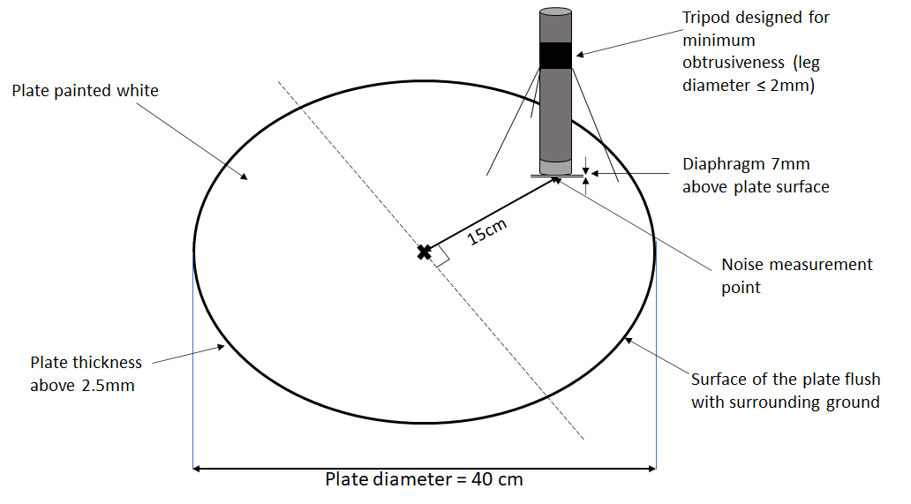

Figure : Example of an inverted microphone set-up for the hover procedure

IM1 NVTOL-TILT.1505 - Microphone system characteristics and set-up

**SOUND INCIDENCE ANGLES ON THE MICROPHONE FOR TAKE-OFF, OVERFLIGHT AND APPROACH PROCEDURES**

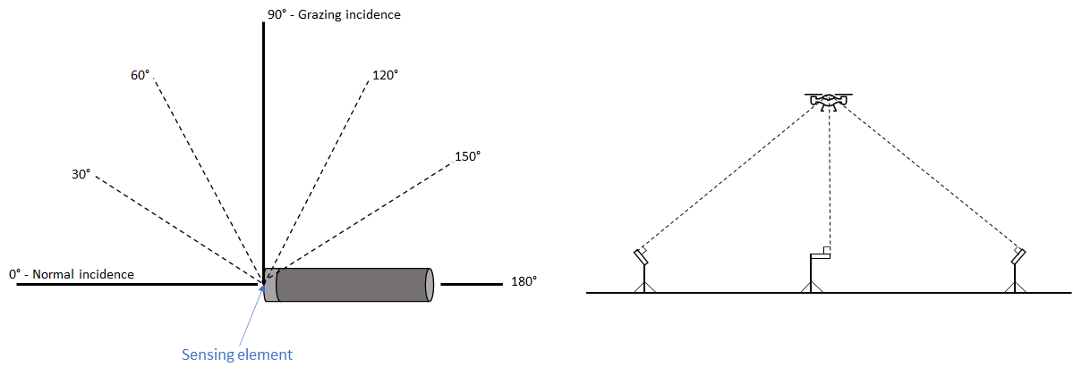

Figure : illustration of sound incidence angles on a microphone and positioning for noise measurements

For the take-off, overflight and approach reference procedures specified respectively in paragraphs “(c)”, “(d)”, and “(e)” of “NVTOL-TILT.1205 - Reference procedures”, Figure 12 depicts sound incidence angles on a microphone, and illustrates microphones positioned for grazing incidence under the flight path and to the side of the flight path of the aircraft.

## NVTOL-TILT.1510 - Recording and reproducing system

1. The complete acoustical signals should be stored using a digital recording and reproducing system with a permanent data storage device. The applicant should not use magnetic tape recorders or digital audiotape. Additionally, systems that use data compression techniques that result in substantial data loss, such as mini-disc (MD) or digital compact cassette (DCC), are not acceptable.
2. For steady sinusoidal electrical signals applied to the input of the entire measurement system exclusive of the microphone systems, but including the microphone preamplifiers, and any other signal-conditioning elements that are considered to be part of the microphone systems, at a selected signal level within 5 dB of that corresponding to the calibration sound pressure level on the reference level range, the time average signal level indicated by the readout device at any one-third octave nominal mid-band frequency from 50 Hz to 10 kHz inclusive should be within ±1.5 dB of that at the calibration check frequency. The frequency response of a measurement system, which includes components that convert analogue signals to digital form, should be within ±0.3 dB of the response at 10 kHz over the frequency range from 10 kHz to 11.2 kHz.
3. For all appropriate level ranges and for steady sinusoidal electrical signals applied to the input of the measurement system exclusive of the microphone systems, but including the microphone preamplifiers, and any other signal conditioning elements that are considered to be part of the microphone systems, at one-third octave nominal mid-band frequencies 50 Hz, 1 kHz and 10 kHz, the level non-linearity should not exceed ±0.5 dB for a linear operating range of at least 50 dB below the upper boundary of the level range. If the calibration check frequency is not one of the 50 Hz, 1 kHz and 10 kHz frequency bands, the check should also be performed at that frequency.
4. The highest steady sinusoidal sound pressure level applied to the input of the measurement system, exclusive of the microphone systems, at which the non-linearity exceeds ±0.4 dB, is used as “post-detection noise” in the background noise subtraction procedure of paragraph “(b)(2)” of “Moc 1 NVTOL-TILT.1600 - Adjustments of the measured sound levels”.
5. On the reference level range, the level corresponding to the calibration sound pressure level should be at least 5 dB, but no more than 30 dB less than the upper boundary of the level range.
6. The linear operating ranges on adjacent level ranges should overlap by at least 50 dB minus the change in attenuation introduced by a change in the level range controls.
7. If switched or variable attenuators are included in the measurement system to permit range changes, they should operate in known intervals of decibel steps.

MoC1 NVTOL-TILT.1510 - Recording and reproducing system

**FREQUENCY RESPONSE**

It is not necessary to include microphone extension cables as configured in the field when showing conformity with the specifications of paragraph “(b)” of “NVTOL-TILT.1510 - Recording and reproducing system”.

MoC2 NVTOL-TILT.1510 - Recording and reproducing system

**LEVEL LINEARITY**

It is not necessary to include microphone extension cables as configured in the field when showing conformity with the specifications of paragraph “(c)” of “NVTOL-TILT.1510 - Recording and reproducing system”.

MoC3 NVTOL-TILT.1510 - Recording and reproducing system

**LINEAR OPERATING RANGES ON ADJACENT LEVEL RANGES**

With respect to the specification of paragraph “(f)” of “NVTOL-TILT.1510 - Recording and reproducing system”, a measurement system should not have level range controls that permit attenuation changes of, for example, either 10 dB or 1 dB. With 10 dB steps, the minimum overlap requested would be 40 dB, and with 1 dB steps the minimum overlap would be 49 dB.

IM1 NVTOL-TILT.1510 - Recording and reproducing system

**LEVEL LINEARITY**

The lower limit of a digital recording system’s usable dynamic range is typically determined by amplitude non-linearity due to quantization error rather than by the presence of a noise floor, the latter being close to 0 dB in digital noise acquisition systems available on the market today. For this reason, the recording system used for the aircraft noise test should be tested to determine the extent of such non-linearity, and the highest noise level at which a non-linearity appears will have to be marked as “post-detection noise” in the adjustment procedure for the effect of background noise according to paragraph “(b)(2)” of “MoC 1 NVTOL-TILT.1600 - Adjustments of the measured sound levels”, for each third-octave band.

IM2 NVTOL-TILT.1510 - Recording and reproducing system

**ATTENUATOR SPECIFICATIONS**

Switched or variable attenuators should have fixed repeatable steps. Any devices in the measurement system that use continuously adjustable gain controls should also have some demonstrable means of being fixed, or locked at a specific setting, to eliminate non-traceable gain errors.

## NVTOL-TILT.1515 - Analysis system

1. The output of the analysis system consists of one-third octave band sound pressure levels as a function of time, obtained by processing the noise signals through an analysis system with the following characteristics:
   1. a set of 24 one-third octave band filters, or their equivalent, having nominal mid-band frequencies from 50 Hz to 10 kHz inclusive;
   2. response and averaging properties in which, in principle, the output from any one-third octave filter band is squared, averaged and displayed or stored as time-averaged sound pressure levels;
   3. the interval between successive sound pressure level samples is 500 ms ± 5 ms for spectral analysis with or without SLOW-time-weighting;
   4. for those analysis systems that do not process the sound pressure signals during the period of time required for readout and/or resetting of the analyser, the loss of data should not exceed a duration of 5 ms; and
   5. the analysis system operates in real time from 50 Hz to at least 12 kHz inclusive. This applies to all operating channels of a multichannel spectral analysis system.
2. The one-third octave band analysis system should conform with the class 1 electrical performance specifications of IEC 61260[2], over the range of one-third octave nominal mid-band frequencies from 50 Hz to 10 kHz inclusive.
3. SLOW-time averaging:
   1. When SLOW-time-averaging is performed in the analyser, the response of the one-third octave band analysis system to a sudden onset or interruption of a constant sinusoidal signal at the respective one-third octave nominal mid-band frequency should be measured at sampling instants 0.5, 1, 1.5 and 2 seconds after the onset and 0.5 and 1 second after interruption. The rising response should be -4 ± 1 dB at 0.5 seconds, -1.75 ± 0.75 dB at 1 second, -1 ± 0.5 dB at 1.5 seconds and -0.5 ± 0.5 dB at 2 seconds relative to the steady-state level. The sum of the rising and corresponding falling shall be -6.5 ± 1 dB, at both 0.5 and 1 seconds. The sum of the rising and falling responses shall be -6.5 dB or less at 1.5 seconds and -7.5 dB or less at 2 seconds, and subsequent times relative to the steady-state levels.
   2. When the one-third octave band sound pressure levels are determined from the output of the analyser without SLOW-time-weighting, SLOW-time-weighting should be simulated in the subsequent processing by the following equation:

Ls(l,k) = 10 log10 [(0.60653) 100.1Ls [l,(k-1)] + (0.39347) 100.1L(l,k)]

where Ls(l,k) is the simulated SLOW-weighted sound pressure level and L(l,k) is the as-measured 0.5 seconds time average sound pressure level determined from the output of the analyser for the kth instant of time and the lth one-third octave band. For k = 1, the SLOW-weighted sound pressure Ls[l,(k-1 = 0)] on the right-hand side is set to 0 dB.

* 1. The instant in time by which a SLOW-time-weighted sound pressure level is characterized is 0.75 seconds earlier than the actual readout time.

1. The resolution of the sound pressure levels, both displayed and stored, should be 0.1 dB or better.

MoC1 NVTOL-TILT.1515 - Analysis system

**CLASS 1 ELECTRICAL PERFORMANCE SPECIFICATIONS**

To meet the specifications of paragraph “(b)” of “NVTOL-TILT.1515 - Analysis system”, the tests of the one-third octave band analysis system should be made according to the methods described in IEC 612602 or by an equivalent procedure agreed with the Agency, for relative attenuation, anti-aliasing filters, real-time operation, level linearity, and filter integrated response (effective bandwidth).

MoC2 NVTOL-TILT.1515 - Analysis system

**SLOW-TIME AVERAGING**

The equation specified in paragraph “(c)(2)” of “NVTOL-TILT.1515 - Analysis system” can be approximated by the following equation for a four-sample averaging process for k = 4:

Ls(l,k) = 10 log10 [(0.13) 100.1L[l,(k-3)] + (0.21) 100.1L[l,(k-2)] + (0.27) 100.1L[l,(k-1)] + (0.39) 100.1L[l,k]]

where Ls(l,k) is the simulated SLOW-weighted sound pressure level and L(l,k) is the as-measured 0.5 seconds time average sound pressure level determined from the output of the analyser for the kth instant of time and the lth one-third octave band. Sound pressure levels calculated by means of either equation are valid for the sixth and subsequent 0.5 seconds data samples, or for times greater than 2.5 seconds after initiation of data analysis.

IM1 NVTOL-TILT.1515 - Analysis system

**CLASS 1 ANALYSER SPECIFICATIONS**

To meet the criteria of paragraph “(b)” of “NVTOL-TILT.1515 - Analysis system”, IEC 612602 specifies the electrical performance specifications of one-third octave band filters, including tolerances for the attenuation in the transition bands (i.e. “skirts”) adjacent to the one-third octave passbands. Most digital one-third octave band analysis systems offer only hardwired filtering algorithms that emulate the response of a traditional third-order analysis filter having a maximally flat passband. However, some analysis systems allow the selection of other filtering algorithms that might not provide equivalent performance. The applicant should demonstrate the effects that alternate filter design response characteristics might have on EPNL values.

The manufacturer can establish the geometric centre frequencies of one-third octave band filters using either Base 2 or Base 10 systems. While the use of either method results in frequencies close to the nominal centre frequencies referred to in Table 2, using test frequencies calculated by a different base-number system than that for which the analyser was designed can result in erroneous values for these adjustments.

IM2 NVTOL-TILT.1515 - Analysis system

**SLOW-TIME AVERAGING**

The specifications of paragraph “(c)(1)” of “NVTOL-TILT.1515 - Analysis system” equate to an exponential averaging process (SLOW weighting) with a nominal 1-second time constant (i.e. 2 seconds averaging time).

The coefficients in the equations of paragraph “(c)(2)” of “NVTOL-TILT.1515 - Analysis system” and associated MoC2 were calculated for use in determining equivalent SLOW-weighted sound pressure levels from samples of 0.5 seconds time average sound pressure levels. The equations cannot be used with data samples where the averaging time differs from 0.5 seconds.

The specification in paragraph “(c)(3)” of “NVTOL-TILT.1515 - Analysis system” of the instant in time at which a SLOW-time-weighted sound pressure level is characterized is needed to correlate the recorded noise with the aircraft position when the noise was emitted, and takes into account the averaging period of the SLOW weighting. For each one-half second data record this instant in time may also be identified as 1.25 seconds after the start of the associated 2-second averaging period.

The first element in determining individual SLOW timestamps for SPL spectra is to establish accurate time-synchronization between the acoustic measurement & analysis system and the aircraft TSPI (Time Space Position Information) system, since the primary purpose of establishing a moment in time for acoustic data is to determine the aircraft position relative to the microphone at the time the sound was emitted. Once adequate time-synchronization has been established between acoustic and position measuring systems, the next element is identification of the moment at which acoustic analysis is initiated. Depending on the synchronization technique used and the specifics of the analysis system, this can be as simple as logging the moment in time at which the operator presses “run” on the analyser, which in many analysis systems is logged automatically and to a great degree of accuracy. In other cases, there may should be some engineering judgment, combined with laboratory-testing to determine the “startup” characteristics of a particular analysis system. In all cases, a clearly defined moment at which the analysis is started is required. This “start time” is needed in order to accurately compute the slow timestamp for any aircraft noise SPL spectrum. Knowing the start time of the analysis allows for determination of the output (readout) time of each SLOW SPL spectrum from the analysis system. Since paragraph “(a)(3)” of “NVTOL-TILT.1515 - Analysis system” specifies 500ms intervals between outputs of SPL data from the analyser, the individual readout time (in seconds) of the kth spectrum will be equal to the start time plus 0.5 times the sequential record number of the spectrum, k:

Readout time (k) = start time + ( 0.5 * k )

For the kth SLOW time-weighted spectrum, the timestamp is the readout time minus 0.75 seconds:

SLOW Timestamp(k) = start time + ( 0.5 * k ) - 0.75 secs

The relationship between analysis start time and individual slow timestamps can be seen in Figure 13.

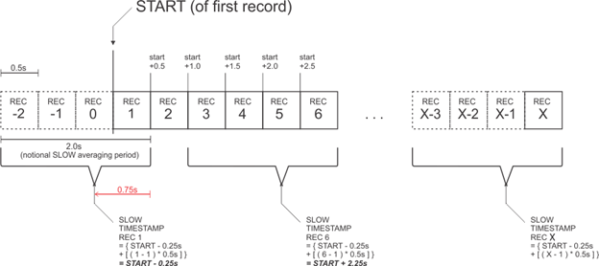

Figure : Determination of SLOW timestamp from analysis start time

## NVTOL-TILT.1520 - Calibration systems

1. Sound calibrator:
   1. The sound calibrator used for checking the overall sensitivity of the noise measurement system as specified in paragraph “(b)” of “NVTOL-TILT.1410 - Noise measurement” should:
      1. conform with the Class 1 specifications of IEC 60942[3];
      2. generate a known sound pressure level using sine wave signals at a known frequency, using the manufacturer’s supplied information on the influence of atmospheric air pressure and temperature.
   2. The sound calibrator output should be determined by a method traceable to a national standards laboratory within 6 months of each noise test.
   3. Changes in the output of the sound calibrator should not be more than 0.2 dB from the previous calibration value.
2. Pink noise generator:
   1. If pink noise is used to determine the corrections for system frequency response specified in paragraph “(b)(4)” of “NVTOL-TILT.1410 - Noise measurement”, then the output of the pink noise generator should be determined within six months of each aircraft noise measurement by a method traceable to a national standards laboratory.
   2. Changes in the output of the pink noise calibrator should not be more than 0.2 dB from the previous calibration value.

SUBPART G - CONFORMITY PROCEDURE

## NVTOL-TILT.1600 - Adjustments of the measured sound levels

1. General
   1. The calibration corrections obtained from the procedure specified in paragraph “(b)(1)” of “NVTOL-TILT.1410 - Noise measurement” are applied to the measured one-third octave band sound pressure levels determined from the output of the analyser.
   2. When applicable, the corrections for incidence specified in paragraph “(b)(2)” of “NVTOL-TILT.1410 - Noise measurement” are applied to the measured one-third octave band sound pressure levels determined from the output of the analyser.
   3. The corrections for the free-field insertion effects of the windscreen specified in paragraph “(b)(3)” of “NVTOL-TILT.1410 - Noise measurement” are applied to the measured one-third octave sound pressure levels determined from the output of the analyser.
   4. The corrections for frequency response specified in paragraph “(b)(4)” of “NVTOL-TILT.1410 - Noise measurement” are applied to the measured one-third octave sound pressure levels determined from the output of the analyser.
   5. The background noise one-third octave band Sound Pressure Levels can be subtracted from the aircraft measured instantaneous one-third octave band Sound Pressure Levels with a procedure agreed with the Agency.
   6. The value of the speed of sound, c, expressed in m/s, is calculated according to the following formula: c = 343.2 ( T / T0 )½, where T is the ambient air temperature in Kelvin and T0 = 293.15 K.
2. Adjustment to reference procedures and conditions for the take-off, overflight and approach reference procedures:
   1. For the take-off, overflight and approach reference procedures specified in “NVTOL-TILT.1205 - Reference procedures”, the sound levels are adjusted according to the specifications of paragraphs “(2)” through to “(9)” to obtain the values of EPNLTOref,i,j, EPNLOVconv,ref,i,j, EPNLOVaero,ref,i,j and EPNLAPref,i,j associated to the ith test run of respectively take-off, overflight in VTOL/conversion mode, overflight in aeroplane mode, and approach procedures, and to the jth reference noise measurement point specified in paragraphs “(a)”, “(b)” and “(c)” of “NVTOL-TILT.1200 - Reference noise measurement points”, where “j” takes values from 1 to 3 (one central and two sideline microphones).
   2. For each ith measured run of the take-off, overflight and approach test procedures specified in “NVTOL-TILT.1405 - Flight test procedures”, the emission coordinates (time, X, Y, and Z) of the reference data point associated with each SPLref,i,j(l,k) at the kth measured instant in time and the lth 1/3-octave band are determined such that the sound emission angle θ on the reference flight path, relative to the reference microphone, is the same value as the sound emission angle of the as-measured data point associated with the spectrum associated with each test-day data point of the ith test run, of the jth reference noise measurement point, at the kth measured instant in time and the lth 1/3-octave band, SPLi,j(l,k). The steps to be followed for this adjustment are specified in paragraph “(3)”. The values of SPLref,i,j(l,k) are then used to compute the resulting EPNLTOref,i,j, EPNLOVconv,ref,i,j, EPNLOVaero,ref,i,j, and EPNLAPref,i,j specified in paragraph “(1)”, following the specifications of paragraphs “(4)” through to “(8)” below.
   3. The spectrum associated with each test-day data point of the ith test run, of the jth reference noise measurement point, at the kth measured instant in time and the lth 1/3-octave band, SPLi,j(l,k), is adjusted for the differences between measured and reference sound propagation path lengths and between measured and reference atmospheric conditions by the following equation:

SPLref,i,j(l,k) = SPLi,j(l,k) + 0.01 [αi,j(l) QKi,j(k) - αref(l) QrefKref,i,j(k)] + 20 log10(QKi,j(k) / QrefKref,i,j(k)), where

* + SPLref,i,j(l,k) is the adjusted spectrum of the ith test run, of the jth reference noise measurement point, at the kth measured instant in time and the lth 1/3-octave band;
  + αi,j(l) is the coefficient of atmospheric absorption (expressed in dB/100m) corresponding to the test conditions of the ith test run, of the jth reference noise measurement point, in the lth 1/3-octave band, determined according to the process specified in “MoC2 NVTOL-TILT.1400 - Test environment conditions”;
  + αref(l) is the coefficient of atmospheric absorption (expressed in dB/100m) corresponding to the reference conditions specified in “NVTOL-TILT.1210 - Reference atmospheric conditions” in the lth 1/3-octave band, determined according to the process specified in “MoC2 NVTOL-TILT.1400 - Test environment conditions”;
  + QKi,j(k) is the measured slant range (in m) between the noise measurement point specified in “NVTOL-TILT.1200 - Reference noise measurement points” and the centre of gravity of the aircraft during the ith test run, of the jth reference noise measurement point, at the kth measured instant in time;
  + QrefKref,i,j(k) is the slant range (in m) between the noise measurement point specified in “NVTOL-TILT.1200 - Reference noise measurement points” and the centre of gravity of the aircraft flying on the reference procedure specified in “NVTOL-TILT.1205 - Reference procedures” at the same sound emission angle θ during the ith test run, of the jth reference noise measurement point, at the kth measured instant in time.
  1. The values of the reference adjusted Perceived Noise Level PNLref,i,j(k) at the kth measured instant in time of the ith run, of the jth reference noise measurement point, are computed from the values of SPLref,i,j(l,k) according to the equations specified in paragraph “(a)(3)(i)” of “NVTOL-TILT.1105 - Calculation of Effective Perceived Noise Level”.
  2. For each value of PNLref,i,j(k), the reference tone-corrected perceived noise level of the ith run, of the jth reference noise measurement point, at the kth instant in time, PNLTref,i,j(k), is computed by adding to PNLref,i,j(k) a tone correction factor C(k) obtained according to the specifications of paragraph “(c)” of “NVTOL-TILT.1105 - Calculation of Effective Perceived Noise Level”.
  3. The maximum value of the reference tone-corrected perceived noise level of the ith run, of the jth reference noise measurement point, PNLTMref,i,j, as well as the associated reference bandsharing adjustment, ΔBref,i,j, and first and last 10 dB down-points, kFref,i,j and kLref,i,j, are determined according to the specifications of paragraphs “(d)” and “(e)” of “NVTOL-TILT.1105 - Calculation of Effective Perceived Noise Level”.
  4. The reference noise duration associated to the ith run, of the jth reference noise measurement point, is calculated as the sum of the reference time intervals for each kth measured instant in time, δtref,I,j(k), within the 10 dB-down period, inclusive, where the values of δtref,i,j(k) are calculated as per the following formula:

δtref,i,j(k) = [ (tref,i,j(k) - tref,i,j(k-1)) + (tref,i,j(k+1) - tref,i,j(k)) ] / 2

where tref,i,j(k) is the reference reception time associated to PNLTref,i,j(k), tref,i,j(k-1) to the point preceding PNLTref,i,j(k), and tref,i,j(k+1) to the point following PNLTref,i,j(k).

* 1. The EPNL associated to the ith run and the jth reference noise measurement point, adjusted and to reference conditions, EPNLref,i,j, is calculated as follows:

$${EPNL}_{ref,i,j}=10\log_{10}\frac{1}{t_{0}}\sum_{k_{Fref,i,j}}^{k_{Lref,i,j}}{{10}^{0.1{PNLT}_{ref,i,j}\left(k\right)}{δt}_{ref,i,j}(k)}$$

where the reference time, t0, is 10 seconds, and the other terms of the equation are defined in paragraphs “(5)”, “(6)” and “(7)”. The value of EPNLref,i,j is set equal to EPNLTOref,i,j, EPNLOVconv,ref,i,j, EPNLOVaero,ref,i,j or EPNLAPref,i,j according to the reference procedure under consideration (take-off, overflight in VTOL/conversion mode, overflight in aeroplane mode, or approach respectively).

* 1. A source noise adjustment should be added to the values of PNLTref,i,j(k) for the ith test run, the jth reference noise measurement point and the kth measured instant in time. The selection of the noise correlating parameter(s) for this source noise adjustment should be agreed with the Agency.
  2. Once the specifications of paragraphs “(1)” through to “(9)” have been followed for each jth of the three reference noise measurement points (one central, two lateral) to obtain the values of EPNLTOref,i,j, EPNLOVconv,ref,i,j, EPNLOVaero,ref,i,j and EPNLAPref,i,j, the three values corresponding to the three reference noise measurement points are averaged as a single number for each reference procedure (take-off, overflight in VTOL/conversion mode, overflight in aeroplane mode, and approach) to obtain EPNLTOref,i, EPNLOVconv,ref,i, EPNLOVaero,ref,i and EPNLAPref,i.

1. Adjustment to reference procedures and conditions for the hover procedure:
   1. For the hover procedure specified in “NVTOL-TILT.1205 - Reference procedures”, the measured sound levels are adjusted according to the specifications of paragraphs “(2)” through to “(4)” to obtain the reference hover sound level LAeqref,i,j associated to the ith test run and to the jth reference noise measurement point specified in paragraph “(d)” of “NVTOL-TILT.1200 - Reference noise measurement points”, where “j” takes values from 1 to 9. The adjustments account for the following effects:
      1. the difference in the sound propagation path lengths between the actual hover flight path of the test aircraft and the reference hover flight path; and
      2. the difference in the atmospheric absorptions between meteorological test conditions and reference conditions.
   2. For each ith test run and jth reference noise measurement point, the reference hover sound level LAeqref,i,j is obtained from the definition specified in “NVTOL-TILT.1110 - Calculation of A-weighted equivalent continuous sound pressure level” through the formula:

$$L_{Aeqref,i,j}=10.\log_{10}\frac{1}{t_{M}}\sum_{k=1}^{N}{{\sum_{l=1}^{24}{ }10}^{0.1{SPL}_{ASref,i,j}(l,k)}∆t}$$

where

* N is the last increment of k corresponding to the duration of tM=30 seconds;
* Δt is the time increment between samples, equal to 0.5 seconds;
* the hover reference time-varying A-frequency-weighted SLOW-time-weighted one-third-octave-band sound pressure level in dB(A) of the ith test run, at the jth reference noise measurement point, at the kth instant of time, and in the lth one-third octave frequency band, SPLASref,I,j(l,k), is obtained as follows:

SPLASref,i,j(l,k) = SPLAS,i,j(l,k) + Δ1,i,j + Δ2,i,j(l) where

* + - SPLAS,i,j(l,k) is the hover measured time-varying A-frequency-weighted SLOW-time-weighted one-third-octave-band sound pressure level of the ith test run, at the jth reference noise measurement point, at the kth instant of time, and in the lth one-third octave frequency band, after application of the adjustments specified in paragraph “(a)”.
    - Δ1,i,j is the adjustment component for the difference in sound propagation path lengths for the ith test run at the jth of the 9 hover reference measurement points specified in paragraph “(d)” of “NVTOL-TILT.1200 - Reference noise measurement points”.
    - Δ2,i,j(l) is the adjustment component for the difference in the atmospheric absorptions for the ith test run, at the jth of the 9 hover reference measurement points specified in paragraph “(d)” of “NVTOL-TILT.1200 - Reference noise measurement points”, in the lth one-third octave frequency band.
  1. The adjustment component for the difference in the sound propagation path lengths accounts for the spherical spreading and is calculated as follows:

Δ1,i,j = 20 log10 (SRi,j / SRref,j)

where:

* + SRi,j is the slant range, in meters, between the jth reference noise measurement point specified in paragraph “(d)” of “NVTOL-TILT.1200 - Reference noise measurement points” and the centre of gravity of the aircraft during the ith run, averaged over the 30 seconds of the measurement duration.
  + SRref,j is the slant range, in meters, between the jth reference noise measurement point specified in paragraph “(d)” of “NVTOL-TILT.1200 - Reference noise measurement points” and the centre of gravity of the aircraft when hovering in the reference position specified in paragraph “(f)(1)” of “NVTOL-TILT.1205 - Reference procedures”.
  1. The adjustment component for the difference in the atmospheric absorption accounts for the difference in the temperature and the relative humidity between the test and the reference atmospheric conditions, and is calculated as follows:

Δ2,i,j(l) = 0.01 [αi(l). SRi,j - αR(l) SRref,j]

where:

* αi(l) is the coefficient of atmospheric absorption (expressed in dB/100m) corresponding to the test conditions of the ith hover test run in the lth 1/3-octave band, determined according to the process specified in “MoC2 NVTOL-TILT.1400 - Test environment conditions”;
* αR(l) is the coefficient of atmospheric absorption (expressed in dB/100m) corresponding to the reference conditions specified in “NVTOL-TILT.1210 - Reference atmospheric conditions” in the lth 1/3-octave band and determined according to the process specified in “MoC2 NVTOL-TILT.1400 - Test environment conditions”; and
* SRi,j and SRref,j are specified in paragraph “(3)”.

MoC1 NVTOL-TILT.1600 - Adjustments of the measured sound levels

**ADJUSTMENTS OF NOISE LEVELS FOR THE EFFECTS OF BACKGROUND NOISE**

Paragraph “(a)(5)” of “NVTOL-TILT.1600 - Adjustments of the measured sound levels” specifies that the background noise present during the test can be subtracted from the aircraft measured noise levels. This MoC provides an acceptable procedure for this background noise subtraction.

1. Definitions

For the purposes of this MoC, the following definitions apply:

***Adjusted level:*** a valid one-third octave band level that has been adjusted for measurement conditions, including:

* the energy contribution of pre-detection noise; and
* frequency-dependent adjustments such as system frequency response, microphone pressure response and free-field grazing incidence response, and windscreen incidence-dependent insertion loss.

***Ambient noise.*** The acoustical noise from sources other than the test aircraft present at the microphone site during aircraft noise measurements. Ambient noise is one component of background noise.

***Background noise.*** The combined noise present in a measurement system from sources other than the test aircraft, which can influence or obscure the aircraft noise levels being measured. Typical elements of background noise include, but are not limited to, ambient noise from sources around the microphone site, thermal electrical noise generated by components in the measurement system, and digitization noise caused by quantization error in digital converters. Some elements of background noise, such as digitization noise, can obscure the aircraft noise signal, while others, such as ambient noise, can also contribute energy to the measured aircraft noise signal.

***Energy subtraction.*** Subtraction of one sound pressure level from another, on an energy basis, in the form of the following:

,

where SPL1 and SPL2 are two sound pressure levels in decibels, with SPL2 being the value subtracted from SPL1.

***Frequency extrapolation.*** A method for reconstruction of high frequency masked data, based on unmasked data in a lower-frequency one-third octave band from the same spectrum.

***High frequency bands.*** The twelve bands from 800 Hz through 10 kHz inclusive (also see “low frequency bands”).

***Last good band (LGB).*** In the adjustment methodology presented in paragraph “(b)” of the current MoC, for any aircraft one-third band spectrum, the LGB is the highest frequency unmasked band within the range of 630 Hz to 10 kHz inclusive, below which there are no masked high frequency bands.

***Low frequency bands.*** The twelve bands from 50 Hz through 630 Hz inclusive (also see “high frequency bands”).

***Masked band.*** Within a single spectrum, any one-third octave band containing a masked level.

***Masked level.*** Any one-third octave band level that is less than or equal to the masking criterion for that band. When a level is identified as being masked, the actual level of aircraft noise in that band has been obscured by background noise and cannot be determined. Masked levels can be reconstructed using frequency extrapolation, time extrapolation or other methods.

***Masking criteria.*** The spectrum of one-third octave band levels below which measured aircraft sound pressure levels are considered masked or obscured by background noise. Masking criteria levels are defined as the greater of pre-detection noise + 3 dB and post-detection noise + 1 dB.

***Post-detection noise.*** The minimum levels below which measured noise levels are not considered valid. They are determined by the amplitude non-linearity characteristics of components in the measurement and analysis system: in a given one-third octave band, the lowest noise level at which linearity has been tested, or the noise level below which the system exhibits non-linearity according to the methods of IEC 61265[4], whichever is the greater, is to be considered post-detection noise. Post-detection noise levels are non-additive (i.e. they do not contribute energy to measured aircraft noise levels).

***Pre-detection noise.*** Any noise that can contribute energy to the measured levels of sound produced by the aircraft, including ambient noise present at the microphone site and active instrumentation noise present in the measurement, record/playback and analysis systems.

***Reconstructed level.*** A level, calculated by frequency extrapolation, time extrapolation, or by other means, which replaces the measured value for a masked band.

***Sound attenuation coefficient.*** The reduction in level of sound within a one-third octave band, in dB per 100 m, due to the effects of atmospheric absorption of sound, calculated according to the specifications of “MoC2 NVTOL-TILT.1400 - Test environment conditions”.

***Time extrapolation.*** A method for reconstruction of high frequency masked data, based on unmasked data in the same one-third octave band, from a different spectrum in the time history.

***Valid or unmasked band.*** Within a single spectrum, any one-third octave band containing a valid level.

***Valid or unmasked level.*** Any one-third octave band level that exceeds the masking criterion for that band.

1. Background noise adjustment procedure
   1. Determination of pre-detection noise

A time-averaged one-third octave band spectrum of pre-detection noise levels for each test run, or group of runs occurring during a short time period, are obtained by recording and analysing ambient noise over a representative period of time (30 seconds or more). Care should be taken to ensure that this “ambient” noise sample reasonably represents that which is present during measured aircraft runs. In recording ambient noise, all gain stages and attenuators are set as they would be during the aircraft runs to ensure that the instrumentation noise is also representative. If multiple gain settings are required for aircraft noise measurements, a separate ambient sample is recorded at each of the settings used.

* 1. Determination of post-detection noise

A one-third octave band spectrum of post-detection noise levels is determined as a result of testing, or from manufacturer’s specifications, for each measurement/analysis configuration used, including different gain and/or sensitivity settings. These minimum valid levels may be determined on the basis of display limitations (e.g. blanking of the displayed indication when levels fall below a certain value), amplitude non-linearity or other non-additive limitations. In cases where more than one component or stage of the measurement/analysis system imposes a set of minimum valid levels, the most restrictive in each one-third octave band should be used. As regards non-linearity, in a given one-third octave band, the lowest noise level at which linearity has been tested, or the noise level below which the system exhibits a non-linearity outside of ±0.4 dB according to the methods of IEC 61265, whichever is the greater, is to be considered post-detection noise.

* 1. Testing of pre-detection noise versus post-detection noise

The validity of pre-detection noise levels is established before these levels can be used to adjust valid aircraft noise levels. Any pre-detection noise level that is equal to or less than the post-detection noise level in a particular one-third octave band is identified as invalid and therefore should not be used in the adjustment procedure.

* 1. Determination of masking criteria

Once the pre-detection noise and post-detection noise spectra are established, the masking criteria can be identified. For each one-third octave band, the valid pre-detection noise level + 3 dB is compared with the post-detection noise level + 1 dB. The highest of these levels is used as the masking criterion for that band. If there is no valid pre-detection noise level for a particular one-third octave band, then the post-detection noise level + 1 dB is used as the masking criterion for that band.

* 1. Identification of masked levels

Each spectrum in the aircraft noise time history is evaluated for masking by comparing the one-third octave band levels against the masking criteria levels. Whenever the aircraft level in a particular band is less than or equal to the associated masking criterion, that aircraft level is considered masked. A record is kept of which bands in each spectrum are masked.

* 1. Determination of Last Good Band (LGB)

For each half-second record, the highest unmasked one-third octave band frequency (“Last Good Band” or “LGB”) is determined by starting at the 630 Hz band and incrementing the band number (i.e. increasing frequency) until a masked band is found. At that point, the LGB for that half-second record is equal to the band below the masked band. The lowest frequency band that can be identified as LGB is the 630 Hz band. In other words, if both the 630 Hz band and the 800 Hz band are masked, no reconstruction of masked levels may be performed for that spectrum, and the thirteen bands between 630 Hz and 10 kHz inclusive is left as is and identified as masked. According to the rejection criteria specified in paragraph “(12)”, such a spectrum is not valid for calculation of EPNL when it occurs within the 10 dB-down period.

* 1. Adjustment of valid levels for background noise

In each half-second spectrum, for each valid band up to and including LGB, an energy-subtraction of the valid pre-detection level from the valid measured level in the aircraft noise time history is performed using the following equation:

$$10 \log_{10}{ }\left[10^{\left(\text{SP}{\text{L}}_{\text{aircraft}}\text{/10}\right)}-10^{\left(\text{SP}{\text{L}}_{\text{Pre-detection}}\text{/10}\right)}\right]$$

Energy subtraction can only be performed on all valid one-third octave band noise levels. For any one-third octave band where there is no valid pre-detection noise level, no energy subtraction may be performed (i.e. this adjustment should not be applied when either the measured aircraft noise time history level or the pre-detection noise level is masked).

* 1. Adjustment of valid levels for measurement conditions

Before any reconstruction can be done for masked levels, the valid levels that have been adjusted for the presence of pre-detection noise are also then adjusted for frequency-dependent adjustments specified in paragraph “(a)” of “NVTOL-TILT.1600 - Adjustments of the measured sound levels” such as system frequency response, microphone pressure response and free-field grazing incidence response, and windscreen incidence-dependent insertion loss. These adjustments should not be applied to masked levels.

* 1. Reconstruction of low frequency masked bands

In cases where a single masked low frequency one-third octave band occurs between two adjacent valid bands, the masked level can be retained, or the arithmetic average of the adjusted levels of the adjacent valid bands may be used in place of the masked level. If the average is used, the level is categorized as reconstructed. However, if masked low frequency bands are found adjacent to other masked low frequency bands, these masked levels are retained and remain categorized as masked. The procedure presented in this section does not provide for any other form of reconstruction for masked low frequency bands.

* 1. Reconstruction of high frequency masked bands

Frequency extrapolation and time extrapolation are the methods used to reconstruct masked one-third octave band levels for bands at frequencies higher than LGB for each half-second record. One-third octave band sound attenuation coefficients (in dB per 100 m) are determined according to the specifications of “MoC2 NVTOL-TILT.1400 - Test environment conditions” before such reconstruction of masked band levels can be performed. Note that sound emission coordinates are also calculated for each record before reconstruction is performed since the procedure is dependent on propagation distance.

* + 1. Frequency extrapolation method

For a spectrum where the LGB is located at or above the 2 kHz one-third octave band, the frequency extrapolation method is used. This method reconstructs masked high frequency bands starting with the level associated with LGB in the same spectrum. The levels for all bands at higher frequencies than LGB are reconstructed using this method. Any frequency-extrapolated levels are categorized as reconstructed. The following equation for frequency extrapolation is used:

$$\text{SP}{\text{L}}_{X}(l,k)=\text{SPL}(l_{\text{LGB}},k)+\left[α(l_{\text{LGB}})-α(l)\right]\frac{\text{SR}(k)}{100}+\left[α_{R}(l)-α_{R}(l_{\text{LGB}})\right]\frac{60}{100}$$

where:

* l is the masked band to be extrapolated;
* k is the record of interest (instant in time);
* lLGB is the LGB in record k;
* SPLX(l,k) is the frequency-extrapolated level in dB for masked band l and half-second record k;
* SPL(lLGB,k) is the level for LGB in record k after all test-day adjustments have been applied, including pre-detection noise energy subtraction, system and microphone adjustments, etc.;
* α(lLGB) is the test-day sound attenuation coefficient (dB per 100 m) for LGB;
* α(l) is the test-day sound attenuation coefficient (dB per 100 m) for band l;
* αR(lLGB) is the reference (25°C, 70 per cent relative humidity (RH)) sound attenuation coefficient (dB per 100 m) for LGB;
* αR(l) is the reference (25°C, 70 per cent RH) sound attenuation coefficient (dB per 100 m) for masked band l; and
* SR(k) is the slant range or sound propagation distance in metres at the time of sound emission for half-second record k, between the aircraft and the microphone.
  + 1. Time extrapolation method

For a spectrum where LGB occurs at or between the 630 Hz one-third octave band and the 1.6 kHz band, the time extrapolation method is to be used. This method reconstructs a masked band in a spectrum from the closest half-second record (i.e. closest in time) for which that band is valid. The levels for all one-third octave bands with frequencies greater than that of LGB are reconstructed using this time extrapolation method. Any time-extrapolated levels are categorized as reconstructed. The time extrapolation to reconstruct masked bands is performed according to the following equation:

$$\text{SP}{\text{L}}_{X}(l,k)=\text{SPL}(l,m)+α(l)\left[\frac{\text{SR}(m)}{100}-\frac{\text{SR}(k)}{100}\right]+20\log\left[\frac{\text{SR}(m)}{\text{SR}(k)}\right]$$

where:

* SPLX(l,k) is the time-extrapolated level in dB for masked band l and half-second record k;
* SPL(l,m) is the adjusted level in dB for band l in half-second record m, which is the nearest record in time to record k in which band l contains a valid level;
* SR(m) is the slant range or sound propagation distance in metres at the time of sound emission for half-second record m, between the aircraft and the microphone;
* SR(k) is the slant range or sound propagation distance in metres at the time of sound emission for half-second record k, between the aircraft and the microphone; and
* α(l) is the test-day sound attenuation coefficient (dB per 100 m) for band l.

Note 1: when using the time-extrapolation method of reconstruction, extrapolating from a previously reconstructed SPL should be avoided. The closest valid SPL in a particular band may not be time-adjacent to the SPL being reconstructed.

Note 2: if there is no valid SPL in a particular band from which to extrapolate (i.e. all SPLs in that band during the test run are masked), then the nearest SPL in that band that has been reconstructed using the frequency-extrapolation method should be used. If this happens, this deviation from the provided time-extrapolation method is documented in the noise report if the time-extrapolated level occurs within the 10 dB down-period.

Note 3: when consecutive one-third octave bands in the range of 2.5 kHz to 10 kHz inclusive are masked, and when no consecutive bands are masked in the region of 800 Hz to 2 kHz inclusive, frequency extrapolation, as described in paragraph “(i)”, is performed on all consecutive masked bands with nominal frequencies greater than 2 kHz.

Note 4: when consecutive one-third octave bands in the range of 800 Hz to 2 kHz inclusive are masked, time extrapolation, as described in paragraph “(ii)”, is performed on all consecutive masked bands with nominal frequencies greater than 630 Hz.

Note 5: in cases where a single masked one-third octave band occurs between two adjacent valid bands, the levels of the adjacent adjusted bands may be arithmetically averaged and the averaged level used in place of the masked level. If the masked level is retained, it is included in the number of masked bands when considering the rejection criteria specified in paragraph “(12)”.

* 1. Handling of spectra after reconstruction of masked bands

After reconstruction of masked data has been performed, the background noise adjustment procedure is complete. The adjusted as-measured data set, comprised of adjusted levels, reconstructed levels, and possibly some masked levels, is then used to obtain the test-day PNLT time history as per paragraph “(c)” of “NVTOL-TILT.1105 - Calculation of Effective Perceived Noise Level”. The identification of masked data is kept accessible for use during the tone correction procedure, since any tone correction that results from the adjustment for background noise may be eliminated from the process of identifying the maximum tone within a spectrum. When this background noise adjustment procedure is used, the band identified as LGB is treated as the last band of the tone correction calculation in the manner prescribed for the 10 kHz band (24th band) in paragraph “(c)(ix)” of “NVTOL-TILT.1105 - Calculation of Effective Perceived Noise Level”, including the calculation of a new slope for band LGB + 1 that equals the slope at LGB (i.e. s′(lLGB + 1,k) = s′(lLGB,k)) in Step 5 of the tone correction procedure.

* 1. Rejection of spectra due to masking

A spectrum becomes invalid if any of the following conditions prevail:

* if, after any reconstruction of masked bands, more than four one-third octave bands retain masked values; or
* for records within one second of the record associated with the PNLTM spectrum (i.e. five half-second data records), if:
  + more than four high frequency bands require reconstruction; or
  + the LGB is located at or below the 3,150 Hz one-third octave band.

Note.— If an invalid spectrum occurs within the 10 dB-down period, the corresponding test run is invalid and should not be used for aircraft noise evaluation purposes.

MoC2 NVTOL-TILT.1600 - Adjustments of the measured sound levels

**DETERMINATION OF REFERENCE-CONDITION NOISE GEOMETRY FOR THE TAKE-OFF, OVERFLIGHT AND APPROACH PROCEDURES**

The present MoC is only relevant to the reference procedures of take-off, overflight and approach as specified in “NVTOL-TILT.1205 - Reference procedures”. It provides a procedure that the applicant might deviate from or improve upon in agreement with the Agency.

“NVTOL-TILT.1600 - Adjustments of the measured sound levels” specifies that the measured sound levels of each test run be adjusted to reference conditions, for which this MoC provides an acceptable method. The methodology presented here is dependent on obtaining an average, straight-line flight path that represents the test aircraft position during noise measurements. It is based on characterizing this average straight-line flight path by a set of single-point descriptors, which can be easily obtained from any method of aircraft TSPI (Time-Space-Position Information) measurement data. Geometry relative to each centre line and lateral microphone of interest is then determined for the test data, including sound emission coordinates (t, X, Y, Z) for each measured acoustic spectrum at time instant k in the acoustic spectral time-history data set. Once the sound emission coordinates have been identified, sound propagation distances and sound emission angles are calculated, which are used to determine the position of the aircraft on the reference flight path. The series of positions on the reference flight path are then used to obtain the effective duration for each spectrum k for the reference condition acoustic data set.

1. Assumptions

* The test aircraft position during noise measurements can be represented by a straight-line flight path.
* The ground reference system used in the figures of this MoC is a right-handed coordinate system, approximated to be fixed to the surface of a flat earth with the x-axis pointing along the reference ground track, the y-axis pointing to the left of the reference ground track, and the z-axis pointing up.
* The point on the ground directly beneath the centre line microphone is the origin of the XYZ coordinate system (X = 0, Y = 0, Z = 0).
* The X-coordinate increases with time from negative to positive values as the aircraft moves through the noise measurement test site.
* The single-point flight path descriptors represent average values over the noise duration specified in paragraph “(e)” of “NVTOL-TILT.1105 - Calculation of Effective Perceived Noise Level”.
* Angular quantities are expressed in radians except where otherwise noted.

1. Steps involved

The methodology can be subdivided into the following sequence:

* The test flight path is characterized as an average straight-line based on descriptors for a single point (see paragraph “(c)”).
* The test aircraft position at time of sound emission of each acoustic spectrum is determined (see paragraph “(d)”).
* The geometric minimum distance between the test flight path and the microphone is calculated (see paragraph “(e)”).
* The test aircraft noise geometry (sound propagation distance and sound emission angle) is determined for each acoustic spectrum (see paragraph “(f)”).
* The reference flight path is determined (see paragraph “(g))”.
* The reference sound propagation distance is determined for each acoustic spectrum (see paragraph “ (h)”).
* The effective duration for each acoustic spectrum is determined (see paragraph “(i)”).

1. Characterization of a straight-line average flight path based on descriptors for a single point

A straight-line flight path can be defined knowing the aircraft position, speed and three-dimensional direction (vector) at a single point in time (see Figure 14). For the method described in this section the “single-point” descriptors are:

tOH is the time at overhead (the time when the aircraft X coordinate = 0.0);

XOH is the aircraft X coordinate at overhead, coinciding with the centre line

microphone, XOH = 0.0;

YOH is the lateral offset of the aircraft from the reference ground track at tOH;

ZOH is the aircraft height above the reference X-Y ground plane at tOH;

VG is the average ground speed over the 10 dB downpoint;

γ is the average climb/descent angle; and

χ is the average lateral cross-track angle.

Note: the average ground speed, VG, used in calculations for aircraft noise geometry, is independent from any cockpit instrumentation and is to be determined from the aircraft position measurements. For reference conditions, the reference ground speed, VGR, is to be determined from the reference climb/descent angle and its relationship to the reference true airspeed value, VR.

The straight-line average aircraft flight path t, X, Y, Z position time history from the single-point flight path descriptors is determined at an appropriate sample rate (typically two times per second) according to the following formulas:

For any relative time, t(p):

X(p) = (t(p) - tOH) (VG cos (χ)) + XOH;

Y(p) = (t(p) - tOH) (VG sin (χ)) + YOH; and

Z(p) = (t(p) - tOH) (VG tan (γ)) + ZOH.

Note: the time index p is not necessarily equal to or synchronised with the kth instant in time of the noise readout samples used throughout this document.

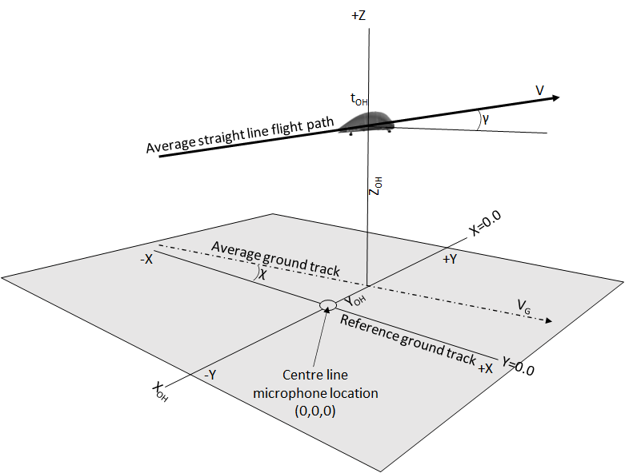

Figure : Single-point flight path descriptors

1. Determination of test aircraft position at time of sound emission of each acoustic spectrum

Because the sound emitted from the aircraft takes a finite time to propagate prior to being received at the measurement microphone, and because during this time, the aircraft has travelled a finite distance along the flight path, it is necessary to determine the time and position coordinates of the aircraft for the point of sound emission for each acoustic record k.

The spectral time-history of measured aircraft noise data includes a series of SLOW sample times as specified in paragraph “(c)” of “NVTOL-TILT.1515 - Analysis system”. For each of these measurement times, tm(k), the associated time of sound emission, tE(k), as well as the sound emission coordinates, XE(k), YE(k), ZE(k), can be determined using information about the microphone, the measured aircraft position and time, and the test speed of sound (c).

The microphone position descriptors are the following:

XMIC is the longitudinal distance along the reference ground track, between microphone location and coordinate system origin (typically 0.0);

YMIC is the lateral distance between microphone location and the reference ground track (typically 0.0 for centre line microphone, and ±150 m for lateral microphones);

ZMIC is the height of ground at microphone location relative to the reference ground plane (typically 0.0); and

HMIC  is the height of microphone above local ground (1.2 m);

An acceptable procedure to determine the aircraft sound emission coordinates corresponding to each measured acoustic data record, k, can be described as follows:

* The speed of sound, c, for the test-day conditions is calculated (see “MoC3 NVTOL-TILT.1600 - Adjustments of the measured sound levels” for the appropriate formula).
* For each pth aircraft position sample in the position time history (defined in paragraph “(c)”), the following parameters are calculated as follows:
  + Slant range between the aircraft and the microphone:

SR(p) = {(X(p) - XMIC)2 + (Y(p) - YMIC)2 + [Z(p) - (ZMIC + HMIC)]2}0.5

* + Sound propagation time:

δtprop(p) = SR(p) / c

* + Sound reception time:

trec(p) = t(p) + δtprop(p)

* + Use linear interpolation to obtain the time of sound emission, tE(k), for each kth measured half-second data record in the spectral time-history, according to the following formula:

tE(k) = t(p2) + [(t(p1) - t(p2)) × (tm(k) - trec(p2)) / (trec(p1) - trec(p2))]

where:

* + - tm(k) is the acoustic measurement time for record k (as specified in paragraph “(c)” of “NVTOL-TILT.1515 - Analysis system”)
    - p1 is the aircraft position record where trec(p) is > tm(k); and
    - p2 is the aircraft position record where trec(p) is < tm(k).
* The sound emission coordinates XE(k), YE(k) and ZE(k) for each kth measured half-second data record are determined as follows:

XE(k) = (tE(k) - tOH) (VG cos (χ)) + XOH;

YE(k) = (tE(k) - tOH) (VG sin (χ)) + YOH; and

ZE(k) = (tE(k) - tOH) (VG tan (γ)) + ZOH.

1. Calculation of the geometric minimum distance between the test flight path and the microphone

The geometrical minimum distance (closest point of approach or “CPA”) along the line from the microphone of interest that intersects the straight-line flight path at right angles is calculated according to the following formula:

CPA = (Gnorm2 + GCPA2)0.5, which is applied after the following intermediate steps have been followed (the relevant parameters being depicted on Figure 15):

* Ydis = YMIC - YOH: lateral distance from microphone to average ground track at tOH.
* Gnorm = Ydis cos (χ): line on the ground from the microphone location that intersects the average ground track at right angles.
* Malt = ZOH - (ZMIC + HMIC): vertical distance of flight path above microphone.
* Ginc = Ydis sin (χ): distance along average ground track between X=0.0 and intersection with Gnorm.
* Zinc = Ginc tan (γ): vertical difference between Galt and ZOH.
* Galt = Malt + Zinc: vertical height of flight path above microphone at intersection of Gnorm and average ground track.
* GCPA = Galt cos (γ): line from the point at the microphone height (HMIC) vertically above the point where Gnorm intersects the average ground track, which intersects the average straight line flight path at right angles.

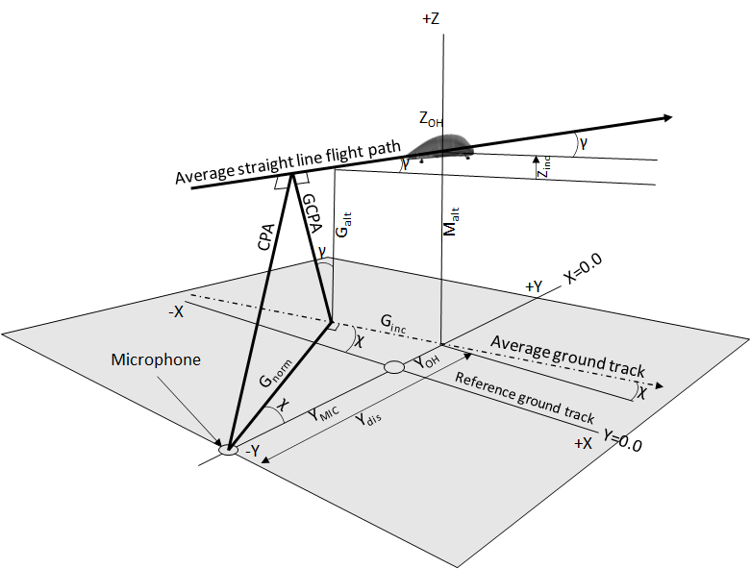

Figure : Detailed CPA geometry

1. Determination of test aircraft noise geometry (sound propagation distance and sound emission angle) for each acoustic spectrum

* The sound propagation distance between the aircraft and the microphone, SR(k), is calculated for each spectrum k in the spectral time-history according to the following formula. It is used for calculations of sound attenuation due to spherical spreading, as well as for sound attenuation due to atmospheric absorption.

SR(k) = [(XE(k) - XMIC)2 + (YE(k) - YMIC)2 + (ZE(k) - [ZMIC + HMIC])2]0.5

* The three-dimensional sound emission angle, θ, is calculated for each spectrum k with the following formulas. It is used for determining the aircraft position on the reference flight path when adjusting noise data to reference conditions.
  + - θ(k) = arcsin (CPA / SR(k)) when the aircraft is positioned prior to CPA;
    - θ(k) = π/2 (90°) when aircraft is positioned at CPA; and
    - θ(k) = π - arcsin (CPA / SR(k)) when aircraft is positioned subsequent to CPA.

1. Determination of reference flight path

The reference flight path of take-off, overflight or approach resulting from the reference procedures specified in “NVTOL-TILT.1205 - Reference procedures” is a straight line with no lateral component (Y=0 along the entire flight path). The following parameters and associated definitions apply to the determination of the reference flight path, some of which are illustrated on Figure 16:

ZOHR is the vertical height of the reference flight path above the reference ground plane at tOH;

VGR is the reference ground speed;

cR is the reference speed of sound, 346.1 m/s (corresponding to a temperature of 25°C);

γR is the reference climb/descent angle;

YMICR is the lateral distance between the reference microphone location and the reference ground track; and

HMICR is the height of the reference microphone (1.2 m) above the reference ground plane.

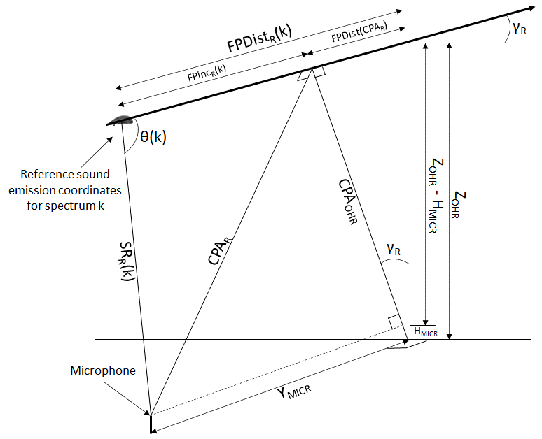

Figure : depiction of reference flight path and sound propagation

The closest point of approach between reference flight path and microphone, CPAR, is calculated as follows:

CPAR = (CPAOHR2 + YMICR2)0.5 where CPAOHR = (ZOHR - HMICR) cos(γR)

1. Determination of reference sound propagation distance for each acoustic spectrum

The reference sound propagation distance at the kth instant in time, SRR(k), is determined through the following formula: SRR(k) = CPAR / sin(θ(k)).

1. Determination of time interval increments for each acoustic spectrum

The effective time interval increments to be used in the calculation of the EPNL according to the specifications of paragraph “(b)(8)” of “NVTOL-TILT.1105 - Calculation of Effective Perceived Noise Level”, δtR(k), are established according to the following formula and steps: δtR(k) = [(tR(k) - tR(k-1)) + (tR(k+1) - tR(k))] / 2, where

* tR(k) = tER(k) + δtpropR(k) is the time of sound reception at the microphone for sound emitted at point k;
* δtpropR(k) = SRR(k) / cR is the sound propagation time for sound emission point k;
* tER(k) = tOH - (FPDistR(k) / VR) is the time of sound emission for point k and VR the true airspeed of the reference procedure specified in “NVTOL-TILT.1205 - Reference procedures”;
* FPDistR(k) = FPDist(CPAR) + FPIncR(k) is the distance along the flight path from point k to the overhead point;
* FPIncR(k) is the distance along the reference flight path from sound emission point k to CPAR, which is calculated as follows:

FPIncR(k) = CPAR / tan(θ(k)), taking its sign from sound emission angle θ(k) as follows:

* + FPIncR(k) is positive when θ(k) < π/2 (i.e. < 90 degrees);
  + FPIncR(k) = 0 when θ(k) = π/2 (i.e. 90 degrees); and
  + FPIncR(k) is negative when θ(k) > π/2 (i.e. > 90 degrees);
* FPDist(CPAR) = CPAOHR tan(γR) is the distance along the reference flight path from CPAR to tOH.

MoC3 NVTOL-TILT.1600 - Adjustments of the measured sound levels

**SOURCE NOISE CORRECTION**

If appropriate, and in coordination with the Agency, the source noise adjustment specified in paragraph “(b)(9)” of “NVTOL-TILT.1600 - Adjustments of the measured sound levels” may be added to the values of reference tone-corrected perceived noise level of the ith run at every kth instant in time, PNLTref,i(k), defined in and established according to paragraph “(b)(5)” of “NVTOL-TILT.1600 - Adjustments of the measured sound levels”.

IM1 NVTOL-TILT.1600 - Adjustments of the measured sound levels

**EFFECTIVE TIME INTERVAL INCREMENTS**

For the take-off, overflight and approach procedures, paragraph “(b)(2)” of “NVTOL-TILT.1600 - Adjustments of the measured sound levels” specifies that the measured PNLT time history be adjusted to the reference profiles specified in “NVTOL-TILT.1205 - Reference procedures”. Consequently, and unless the test and reference conditions are identical, the reception time intervals between the reference data points will typically neither be equally spaced nor equal to one-half second.

IM2 NVTOL-TILT.1600 - Adjustments of the measured sound levels

**DETERMINATION OF THE MAXIMUM PNLTM**

The procedure specified in paragraph “(b)(6)” of “NVTOL-TILT.1600 - Adjustments of the measured sound levels” specifies how to determine the maximum value of the reference tone-corrected perceived noise level of the ith run, PNLTMref,i, for the take-off, overflight and approach procedures. Due to differences between test and reference conditions, it is possible that PNLTMref,i will not occur at the data point associated with the measured maximum PNLT of the ith run, PNLTMi. The determination of PNLTMref,i is independent of PNLTMi.

IM3 NVTOL-TILT.1600 - Adjustments of the measured sound levels

**SOURCE NOISE ADJUSTMENT**

For the take-off, overflight and approach procedures, paragraph “(b)(9)” of “NVTOL-TILT.1600 - Adjustments of the measured sound levels” specifies that a source noise adjustment be applied to each reference tone-corrected perceived noise level of the ith run at the kth instant in time. The selection of the correlating noise parameter(s) should account for the possible impact of the following deviations between the flight test procedures of “NVTOL-TILT.1405 - Flight test procedures” and the reference procedures of “NVTOL-TILT.1205 - Reference procedures”, either combined or taken in isolation:

(A) airspeed deviations; and/or

(B) individual rotor speed deviations; and/or

(C) power output in relation to battery State of Charge.

## NVTOL-TILT.1605 - Satisfying maximum allowable noise levels

1. Each reference sound level, EPNLTOref, EPNLOVconv,ref, EPNLOVaero,ref, EPNLAPref, and LAeqref, corresponding to the take-off, overflight in VTOL/conversion mode, overflight in aeroplane mode, approach and hover reference procedures specified in “NVTOL-TILT.1205 - Reference procedures” respectively, should not exceed the corresponding values specified in Subpart D;
2. The 90 per cent confidence interval should be within EPNLTOref ±1.5 EPNdB, EPNLOVconv,ref ±1.5 EPNdB, EPNLOVaero,ref ±1.5 EPNdB, EPNLAPref ±1.5 EPNdB and LAeqref ±1.5 dB(A) respectively.
3. For the take-off procedure:
   1. The reference sound level, EPNLTOref,is calculated from the reference sound levels associated to each ith run, EPNLTOref,i, as follows: ${EPNL}_{TOref} = \frac{1}{n}\left\{\sum_{i=1}^{n}{{EPNL}_{TOref,i}}\right\}$

where n is the number of valid runs acquired for the take-off procedure.

* 1. The 90 per cent confidence interval associated to the take-off reference sound level, CI_EPNLTOref, is calculated using the Student’s t-distribution for all reference sound levels, EPNLTOref,i, with the following formula:

${CI_EPNL}_{TOref}={EPNL}_{TOref}± t_{\left(95,ζ\right)}\frac{{s_EPNL}_{TOref}}{\sqrt{n}}$

where:

* t95,ζ is the 95th percentile of the one-tailed Student’s t-distribution and depends on the degree of freedom ζ, where ζ = n-1.
* ${s_EPNL}_{TOref}= \sqrt{\frac{\sum_{i=1}^{n}{{({EPNL}_{TOref,i}-EPNL_{TOref})}^{2}}}{n-1}}$ is the estimate of the standard deviation associated to EPNLTOref.

1. For the overflight procedure in VTOL/conversion mode:
   1. The reference sound level, EPNLOVconv,ref,is calculated from the reference sound levels associated to each ith run, EPNLOVconv,ref,i, as follows: ${EPNL}_{OVconv,ref} = \frac{1}{n}\left\{\sum_{i=1}^{n}{{EPNL}_{OVconv,ref,i}}\right\}$

where n is the number of valid runs acquired for the overflight procedure in VTOL/conversion mode.

* 1. The 90 per cent confidence interval associated to the overflight reference sound level in VTOL/conversion mode, CI_EPNLOVconv,ref, is calculated using the Student’s t-distribution for all reference sound levels, EPNLOVconv,ref,i, with the following formula:

${CI_EPNL}_{OVconv,ref}={EPNL}_{OVconv,ref}± t_{\left(95,ζ\right)}\frac{{s_EPNL}_{OVconv,ref}}{\sqrt{n}}$

where:

* t95,ζ is the 95th percentile of the one-tailed Student’s t-distribution and depends on the degree of freedom ζ, where ζ = n-1.
* ${s_EPNL}_{OVconv,ref}= \sqrt{\frac{\sum_{i=1}^{n}{{({EPNL}_{OVconv,ref,i}-EPNL_{OVconv,ref})}^{2}}}{n-1}}$ is the estimate of the standard deviation associated to EPNLOVconv,ref.

1. For the overflight procedure in aeroplane mode:
   1. The reference sound level, EPNLOVaero,ref,is calculated from the reference sound levels associated to each ith run, EPNLOVaero,ref,i, as follows: ${EPNL}_{OVaero,ref} = \frac{1}{n}\left\{\sum_{i=1}^{n}{{EPNL}_{OVaero,ref,i}}\right\}$

where n is the number of valid runs acquired for the overflight procedure in aeroplane mode.

* 1. The 90 per cent confidence interval associated to the overflight reference sound level in aeroplane mode, CI_EPNLOVaero,ref, is calculated using the Student’s t-distribution for all reference sound levels, EPNLOVaero,ref,i, with the following formula:

${CI_EPNL}_{OVaero,ref}={EPNL}_{OVaero,ref}± t_{\left(95,ζ\right)}\frac{{s_EPNL}_{OVaero,ref}}{\sqrt{n}}$

where:

* t95,ζ is the 95th percentile of the one-tailed Student’s t-distribution and depends on the degree of freedom ζ, where ζ = n-1.
* ${s_EPNL}_{OVaero,ref}= \sqrt{\frac{\sum_{i=1}^{n}{{({EPNL}_{OVaero,ref,i}-EPNL_{OVaero,ref})}^{2}}}{n-1}}$ is the estimate of the standard deviation associated to EPNLOVaero,ref.

1. For the approach procedure:
   1. The reference sound level, EPNLAPref,is calculated from the reference sound levels associated to each ith run, EPNLAPref,i, as follows: ${EPNL}_{APref} = \frac{1}{n}\left\{\sum_{i=1}^{n}{{EPNL}_{APref,i}}\right\}$

where n is the number of valid runs acquired for the approach procedure.

* 1. The 90 per cent confidence interval associated to the approach reference sound level, CI_EPNLAPref, is calculated using the Student’s t-distribution for all reference sound levels, EPNLAPref,i, with the following formula:

${CI_EPNL}_{APref}={EPNL}_{APref}± t_{\left(95,ζ\right)}\frac{{s_EPNL}_{APref}}{\sqrt{n}}$

where:

* t95,ζ is the 95th percentile of the one-tailed Student’s t-distribution and depends on the degree of freedom ζ, where ζ = n-1.
* ${s_EPNL}_{APref}= \sqrt{\frac{\sum_{i=1}^{n}{{({EPNL}_{APref,i}-EPNL_{APref})}^{2}}}{n-1}}$ is the estimate of the standard deviation associated to EPNLAPref.

1. For the hover procedure:
   1. The arithmetic average sound level, LAeqref_av,j at the jth reference noise position specified in paragraph “(d)” of “NVTOL-TILT.1200 - Reference noise measurement points”,is calculated from all reference sound levels, LAeqref,i,j, as follows:

$L_{{Aeqref}_{av},j} = \frac{1}{n}\left\{\sum_{i=1}^{n}{L_{Aeqref,i,j}}\right\}$

* where LAeqref,i,j is the reference sound level of the ith run at the jth reference noise position specified in paragraph “(d)” of “NVTOL-TILT.1200 - Reference noise measurement points” over the n valid runs of the hover procedure.
  1. The 90 per cent confidence interval, CI_LAeqref_av,j, is calculated for the average sound level, LAeqref_av,j, using the Student’s t-distribution for all reference sound levels, LAeqref,i,j, with the following formula:

${CI_L}_{{Aeqref}_{av,j}}=L_{{Aeqref}_{av,j}}± t_{\left(95,ζ\right)}\frac{{s_L}_{{Aeqref}_{av,j}}}{\sqrt{n}}$

where:

* t95,ζ is the 95th percentile of the one-tailed Student’s t-distribution and depends on the degree of freedom ζ, where ζ = n-1.
* ${s_L}_{{Aeqref}_{av,j}}= \sqrt{\frac{\sum_{i=1}^{n}{{(L_{Aeqref,i,j}-L_{{Aeqref}_{av},j})}^{2}}}{n-1}}$ is the estimate of the standard deviation associated to LAeqref_av,j
* n is the number of valid runs.

IM1 NVTOL-TILT.1605 - Satisfying maximum allowable noise levels

**90 PER CENT CONFIDENCE INTERVAL**

1. The sound levels that are adjusted are measured under conditions as similar as possible for each reference procedure. However, the individual sound levels are not identical due to the measurement variability. The 90% confidence interval provides the range in which the unknown true average value of the sound level can be found with a 90% confidence level.
2. Since the sound levels are obtained under conditions as similar as possible, they are assumed to constitute a random sample of a normally distributed population with a true mean population and a standard deviation. However, since the number of measured sound levels is small, the Student’s t-distribution is used instead of the normal distribution to calculate the 90% confidence interval.
3. The values of the 95th percentile of the one-tailed Student’s t-distribution, t.95,ζ, as a function of the degree of freedom, ζ, for a 90% confidence interval are listed below. The degree of freedom, ζ, is equal to n-1, where n is the number of valid runs.

|  |  |
| --- | --- |
| **ζ** | **t.95,ζ** |
| 1 | 6.314 |
| 2 | 2.920 |
| 3 | 2.353 |
| 4 | 2.132 |
| 5 | 2.015 |
| 6 | 1.943 |
| 7 | 1.895 |
| 8 | 1.860 |
| 9 | 1.833 |
| 10 | 1.812 |
| 12 | 1.782 |
| 14 | 1.761 |
| 16 | 1.746 |
| 18 | 1.734 |
| 20 | 1.725 |
| 24 | 1.711 |
| 30 | 1.697 |
| 60 | 1.671 |
| >60 | 1.645 |

1. Worked example of the calculation of the 90 per cent Confidence Interval

This IM subsection provides a worked example that can be followed to calculate the 90 per cent Confidence Interval value associated to the reference noise levels at take-off, overflight in VTOL/conversion and aeroplane modes, approach and hover, as per the specifications of the respective paragraphs “(c)(2)”, “(d)(2)”, “(f)(2)”, or “(g)(2)” of “NVTOL-TILT.1605 - Satisfying maximum allowable noise levels”.

Assuming that there are 8 valid runs at take-off and that the reference sound levels associated to each ith run, EPNLTOref,i (already averaged over the three noise measurement stations with index “j”, as per the specifications of “NVTOL-TILT.1600 - Adjustments of the measured sound levels”), are as follows:

|  |  |
| --- | --- |
| Run number (“i”) | EPNLTOref,i [EPNdB] |
| 1 | 70.5 |
| 2 | 70.0 |
| 3 | 73.2 |
| 4 | 69.8 |
| 5 | 67.8 |
| 6 | 71.3 |
| 7 | 70.1 |
| 8 | 69.8 |

Using the terminology specified in paragraph “(c)(2)” of “NVTOL-TILT.1605 - Satisfying maximum allowable noise levels”, the number of valid runs “n” is equal to 8, the degree of freedom “ζ” is n-1=7, and the value of “t95,ζ”, the 95th percentile of the one-tailed Student’s t-distribution, is 1.895, as extracted from the table in paragraph “(c)” of NVTOL-TILT.1605 - Satisfying maximum allowable noise levels”. This leads to the following values:

* The reference sound level, EPNLTOref, is obtained as follows:
$${EPNL}_{TOref} = \frac{1}{n}\left\{\sum_{i=1}^{n}{{EPNL}_{TOref,i}}\right\}=70.3 EPNdB$$

* The estimate of the standard deviation associated to EPNLTOref is:
$${s_EPNL}_{TOref}= \sqrt{\frac{\sum_{i=1}^{n}{{({EPNL}_{TOref,i}-EPNL_{TOref})}^{2}}}{n-1}}=1.527 EPNdB$$

* The 90 per cent confidence interval associated to the take-off reference sound level, CI_EPNLTOref, is:

$${CI_EPNL}_{TOref}={EPNL}_{TOref}± t_{\left(95,ζ\right)}\frac{{s_EPNL}_{TOref}}{\sqrt{n}}=70.3±1.023 EPNdB$$

SUBPART H - REPORTING

## NVTOL-TILT.1700 - Noise data

The applicant should report the following noise data to the Agency:

1. For the reference take-off procedure,
   1. All reference flight profile parameters relevant to the specifications set forth in paragraph “(c)” of “NVTOL-TILT.1205 - Reference procedures”;
   2. The reference sound level, EPNLTOref, and its associated 90 per cent confidence interval CI_EPNLTOref, along with the intermediate calculation steps relevant to the adjustment specifications of “NVTOL-TILT.1600 - Adjustments of the measured sound levels”;
   3. the margin to the corresponding maximum allowable noise level specified in Subpart D;
   4. for each ith valid run of the procedure:
      1. the reference sound levels EPNLTOref,i;
      2. the details of the adjustment calculations carried out as specified in “NVTOL-TILT.1600 - Adjustments of the measured sound levels”. These include the measured sound pressure levels presented in one-third octave band levels conforming with the specifications of “NVTOL-TILT.1515 - Analysis system”;
2. For the reference overflight procedure in VTOL/conversion mode,
   1. All reference flight profile parameters relevant to the specifications set forth in paragraph “(d)” of “NVTOL-TILT.1205 - Reference procedures”;
   2. The reference sound level, EPNLOVconv,ref, and its associated 90 per cent confidence interval CI_EPNLOVconv,ref, along with the intermediate calculation steps relevant to the adjustment specifications of “NVTOL-TILT.1600 - Adjustments of the measured sound levels”;
   3. the margin to the corresponding maximum allowable noise level specified in Subpart D;
   4. for each ith valid run of the procedure:
      1. the reference sound levels EPNLOVconv,ref,i;
      2. the details of the adjustment calculations carried out as specified in “NVTOL-TILT.1600 - Adjustments of the measured sound levels”. These include the measured sound pressure levels presented in one-third octave band levels conforming with the specifications of “NVTOL-TILT.1515 - Analysis system”;
3. For the reference overflight procedure in aeroplane mode,
   1. All reference flight profile parameters relevant to the specifications set forth in paragraph “(d)” of “NVTOL-TILT.1205 - Reference procedures”;
   2. The reference sound level, EPNLOVaero,ref, and its associated 90 per cent confidence interval CI_EPNLOVaero,ref, along with the intermediate calculation steps relevant to the adjustment specifications of “NVTOL-TILT.1600 - Adjustments of the measured sound levels”;
   3. the margin to the corresponding maximum allowable noise level specified in Subpart D;
   4. for each ith valid run of the procedure:
      1. the reference sound levels EPNLOVaero,ref,i;
      2. the details of the adjustment calculations carried out as specified in “NVTOL-TILT.1600 - Adjustments of the measured sound levels”. These include the measured sound pressure levels presented in one-third octave band levels conforming with the specifications of “NVTOL-TILT.1515 - Analysis system”;
4. For the reference approach procedure,
   1. All reference flight profile parameters relevant to the specifications set forth in paragraph “(e)” of “NVTOL-TILT.1205 - Reference procedures”;
   2. The reference sound level, EPNLAPref, and its associated 90 per cent confidence interval CI_EPNLApref, along with the intermediate calculation steps relevant to the adjustment specifications of “NVTOL-TILT.1600 - Adjustments of the measured sound levels”;
   3. the margin to the corresponding maximum allowable noise level specified in Subpart D;
   4. for each ith valid run of the procedure:
      1. the reference sound levels EPNLOvref,I;
      2. the details of the adjustment calculations carried out as specified in “NVTOL-TILT.1600 - Adjustments of the measured sound levels”. These include the measured sound pressure levels presented in one-third octave band levels conforming with the specifications of “NVTOL-TILT.1515 - Analysis system”;
5. For the reference hover procedure,
   1. The reference sound levels, LAeqref_av,j at the jth reference noise position specified in paragraph “(d)” of “NVTOL-TILT.1200 - Reference noise measurement points”, and their associated 90 per cent confidence interval CI_LAeqref_av,j, along with the intermediate calculation steps relevant to the adjustment specifications of paragraph “(c)” of “NVTOL-TILT.1600 - Adjustments of the measured sound levels”;
   2. for each ith valid run of the procedure and each jth reference noise position specified in paragraph “(d)” of “NVTOL-TILT.1200 - Reference noise measurement points”, the details of the adjustment calculations carried out as specified in “NVTOL-TILT.1600 - Adjustments of the measured sound levels”. These include the measured sound pressure levels presented in one-third octave band levels conforming with the specifications of “NVTOL-TILT.1515 - Analysis system”.
6. For all procedures,
   1. all checks and calibration corrections specified in paragraph “(b)” of “NVTOL-TILT.1410 - Noise measurement”, including those for the environmental effects on sound calibrator output level; and
   2. the corrections for free-field grazing incidence frequency response of the microphone system specified in “NVTOL-TILT.1505 - Microphone system characteristics and set-up”.

## NVTOL-TILT.1705 - Aircraft information

The applicant should report the following information related to the test aircraft to the Agency:

1. The type, model and serial numbers, if applicable, of the test aircraft vehicle and its rotors or propellers;
2. A list and description of all noise-germane parts of the test aircraft vehicle that deviate from production design, and due justification to substantiate why these deviations do not affect the acoustic characteristics of the test aircraft vehicle, in line with the specification of paragraph “(a)” of “NVTOL-TILT.1405 - Flight test procedures”;
3. The aircraft MTOM;
4. The values of all parameters considered in the specifications of “NVTOL-TILT.1205 - Reference procedures”; and
5. The identification of the aircraft point being tracked for the aircraft positioning and details of the transposition from that point to the centre of gravity of the aircraft;

## NVTOL-TILT.1710 - Additional test information

The applicant should report the following additional test information to the Agency:

1. For each run:
   1. The date and time;
   2. The temperatures measured at 10 m and at the aircraft location;
   3. The relative humidity;
   4. The average wind speed and the average wind direction;
   5. The atmospheric pressure;
   6. The value of the ground speed for the overflight test procedure;
   7. The true air speed;
   8. The climb or descent gradient;
2. For each rejected run, a short description of the reason for the rejection;
3. The type of equipment used for the measurement and analysis of the sound levels;
4. The type of meteorological instruments used during the test;
5. A description of the local topography, ground cover, and any event that might interfere with the sound level recording.

1. In case of SC, the associated Interpretative Material and/or Means of Compliance may be published for awareness only and they are not subject to public consultation.
2. IEC 61260 Part 1, entitled “Electroacoustics — Octave-band and fractional-octave-band filters”, Edition 1.0, 2014-02.
3. IEC 60942 Edition 4.0 2017-11 entitled “Electroacoustics — Sound calibrators”.
4. IEC 61265 entitled “Electroacoustics - Instruments for measurement of aircraft noise - Performance specifications for systems to measure sound pressure levels in noise certification of aircraft”, Edition 2.0, 2018-05.